|  |  |  |
| --- | --- | --- |
|  |  | G1405班家校同心桥 第一周 |

2015年9月12日星期六

班刊设计人员：蒋少康，刘雨祺，董正浩

# 班主任寄语

# 一周回放

1. **常规分**

|  |  |  |  |  |  |  |  |  |  |  |  |  |
| --- | --- | --- | --- | --- | --- | --- | --- | --- | --- | --- | --- | --- |
| **团队名称** | **学号** | **语文** | **数学** | **英语** | **物理** | **化学** | **生物** | **纪律** | **卫生** | **寝室** | **总分** | **团分** |
| **一团** | 28 | **1** |  |  |  |  |  |  |  | **2** | **3** | **5.1** |
| 12 | **2** |  |  |  |  |  |  |  | **4** | **6** |
| 52 | **5** |  |  |  |  |  | **1** |  | **2.5** | **8.5** |
| 5 | **2** |  |  |  |  |  |  |  | **0** | **2** |
| 21 | **1** |  |  |  |  |  | **2** |  | **3.5** | **6.5** |
| 36 | **2** |  | **-1** |  |  |  |  |  |  | **1** |
| 45 | **5** |  |  |  |  |  |  |  | **0.5** | **5.5** |
| 51 | **5** |  |  |  |  |  | **2** |  | **1** | **8** |
| **二团** | 57 | **3** |  |  |  |  |  |  |  |  | **3** | **-1** |
| 47 | **1** |  |  |  |  |  |  |  |  | **1** |
| 53 | **-1** |  | **1** |  | **-6** |  |  |  | **3** | **-3** |
| 40 | **0** |  | **1** |  |  |  |  |  |  | **1** |
| 32 | **2** |  |  | **-4** |  |  |  |  | **4** | **2** |
| 16 | **3** |  |  |  | **-2** | **-2** | **2** |  | **4** | **5** |
| 1 | **1** |  | **1** | **-4** | **-4** | **-4** |  |  | **-1** | **-11** |
| 17 | **2** |  | **1** | **-4** |  | **-2** | **1** |  |  | **-2** |
| **三团** | 39 | **-6** | **-8** | **-1** | **-10** | **-10** | **-4** |  |  |  | **-39** | **-5** |
| 46 | **6** | **-2** |  |  |  |  |  |  |  | **4** |
| 56 | **6** |  |  |  |  |  |  |  | **1** | **7** |
| 35 | **-3** | **-2** |  | **-8** | **-4** |  |  |  |  | **-17** |
| 23 | **2** |  |  |  |  |  |  |  | **2** | **4** |
| 27 | **0** | **-2** |  |  |  |  |  |  | **-2** | **-4** |
| 11 | **5** |  |  |  |  |  | **1** |  | **3** | **9** |
| 6 | **0** |  |  |  | **-2** |  | **2** |  | **-1** | **-1** |
| **四团** | 49 | **5** |  |  |  |  |  |  |  | **3** | **8** | **2.8** |
| 48 | **4** |  |  |  |  |  |  |  | **2.5** | **6.5** |
| 55 | **2** | **-2** |  | **-2** |  |  | **-1** |  | **2** | **-1** |
| 50 | **5** |  |  |  | **-2** |  | **-1** |  | **2** | **4** |
| 31 | **2** |  | **-1** |  |  |  |  |  | **2** | **3** |
| 18 | **0** |  |  |  |  | **-2** |  |  | **-1** | **-3** |
| 15 | **3** |  |  |  |  |  |  |  | **2** | **5** |
| 2 | **-2** |  |  |  |  |  | **1** |  | **1** | **0** |
| **五团** | 60 | **0** | **-2** | **1** | **-2** | **-2** | **-2** |  |  | **2** | **-5** | **-2** |
| 59 | **2** |  |  |  |  |  |  |  | **3.5** | **5.5** |
| 43 | **3** |  |  |  |  |  |  |  | **3** | **6** |
| 34 | **1** |  | **1** |  | **-1** | **-1** | **1** |  | **1** | **2** |
| 26 | **-3** | **-6** |  | **-8** | **-3** | **-3** |  |  |  | **-23** |
| 22 | **1** |  | **1** | **-2** | **-3** | **-3** | **1.5** |  | **-2** | **-7** |
| 7 | **1** |  | **1** |  |  |  |  |  | **1.5** | **3.5** |
| 10 | **2** |  |  |  | **-1** | **-1** | **1** |  | **3** | **4** |
| **六团** | 58 | **4** |  | **1** |  |  |  |  |  | **1** | **6** | **2.9** |
| 54 | **3** |  |  |  |  |  |  |  | **1** | **4** |
| 30 | **2** |  |  |  |  |  |  |  | **3** | **5** |
| 44 | **2** |  | **1** |  |  |  | **2** |  | **0.5** | **5.5** |
| 19 | **-4** | **-4** |  | **-4** |  |  |  |  |  | **-12** |
| 14 | **1** |  | **1** |  |  |  |  |  | **3** | **5** |
| 3 | **4** |  |  |  |  |  |  |  | **3** | **7** |
| 38 | **3** |  |  | **-2** |  |  | **-1** |  | **3** | **3** |
| **七团** | 8 | **5** |  |  |  |  |  | **1** |  | **2** | **8** | **2.2** |
| 33 | **0** |  |  |  |  |  |  |  | **3** | **3** |
| 9 | **1** |  |  |  |  |  |  |  | **4** | **5** |
| 24 | **0** |  |  |  |  |  | **1** |  |  | **1** |
| 25 | **0** |  |  | **-2** |  |  |  |  | **1** | **-1** |
| 63 | **0** |  |  |  |  |  | **1** |  |  | **1** |
| 64 | **0** |  | **-1** | **-2** |  |  |  |  |  | **-3** |
| 41 | **2** |  |  |  |  |  |  |  | **1.5** | **3.5** |
| **八团** | 4 | **-1** |  |  |  |  |  |  |  | **1.5** | **0.5** | **1.6** |
| 13 | **-1** |  | **-1** | **-2** |  |  | **-1** |  | **4** | **-1** |
| 20 | **2** |  | **-1** |  |  |  | **1** |  | **3** | **5** |
| 29 | **0** |  |  |  |  |  | **1** |  | **0** | **1** |
| 37 | **0** | **-2** | **-1** | **-2** |  |  | **0.5** |  | **-2** | **-7** |
| 42 | **5** |  |  |  |  |  |  |  |  | **5** |
| 61 | **1** |  |  |  |  |  | **1** |  | **0.5** | **2.5** |
| 62 | **3** |  |  |  |  |  |  |  | **3** | **6** |

1. **班级活动照片**

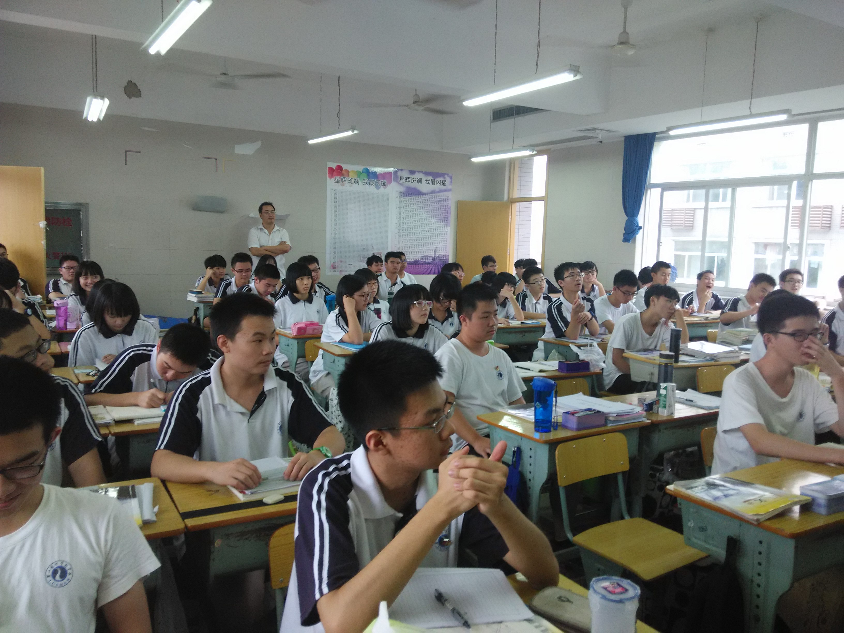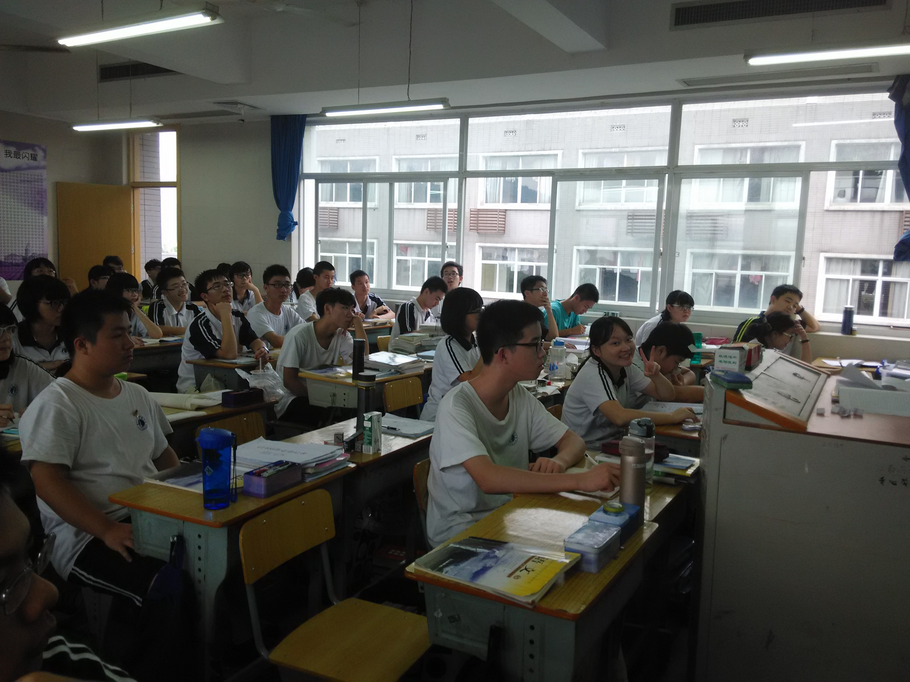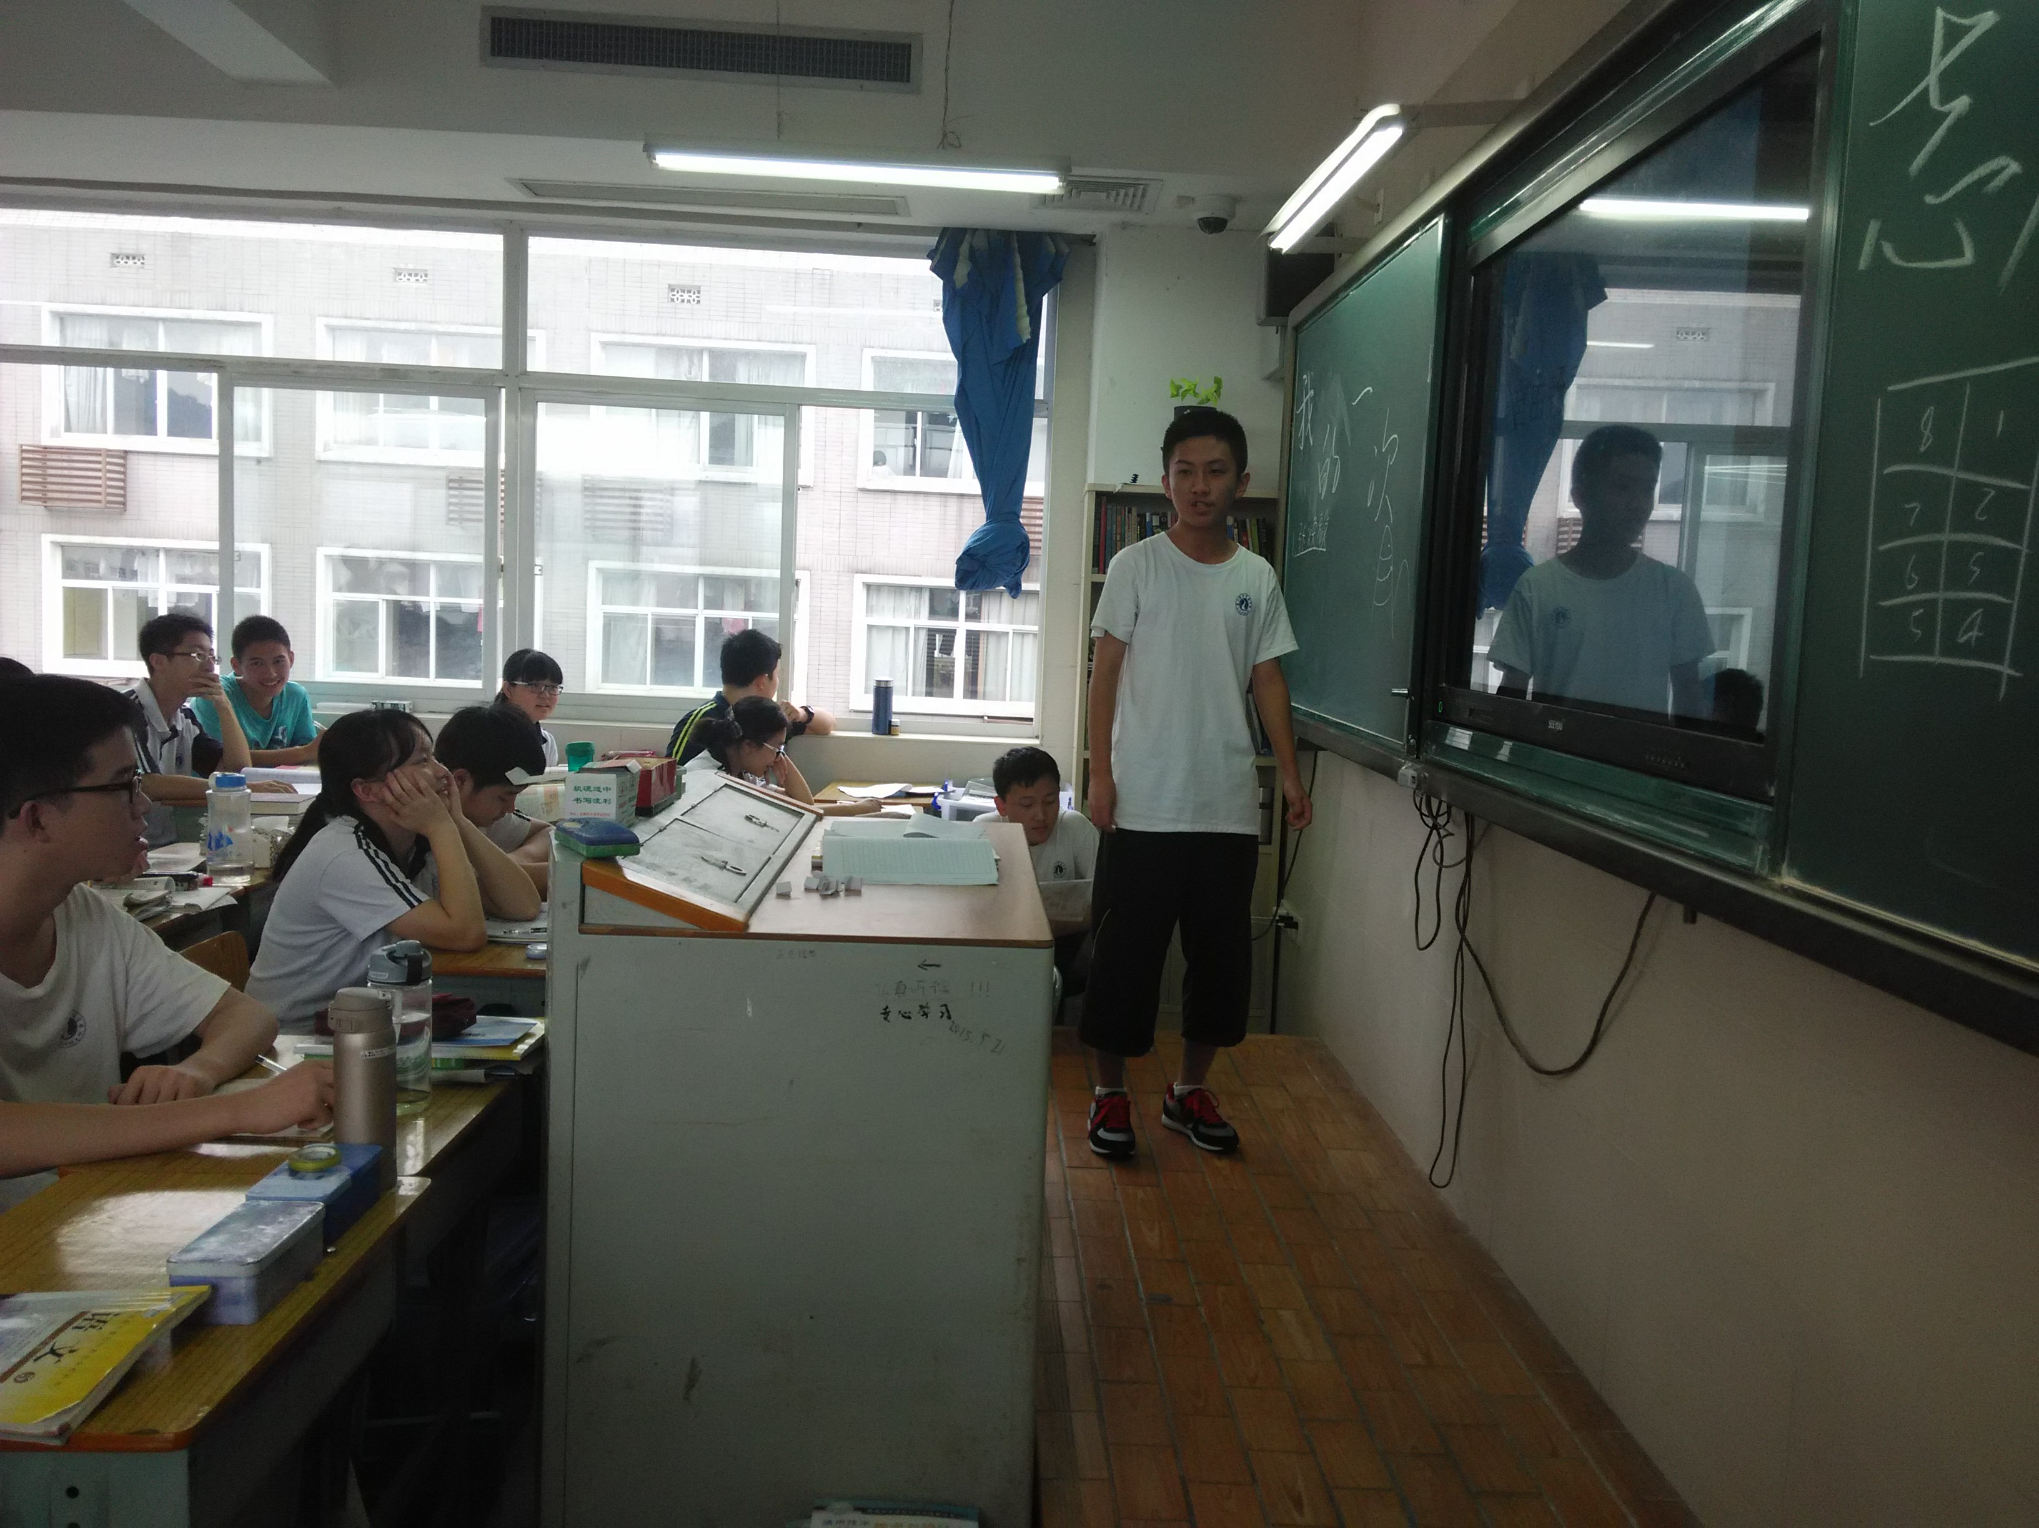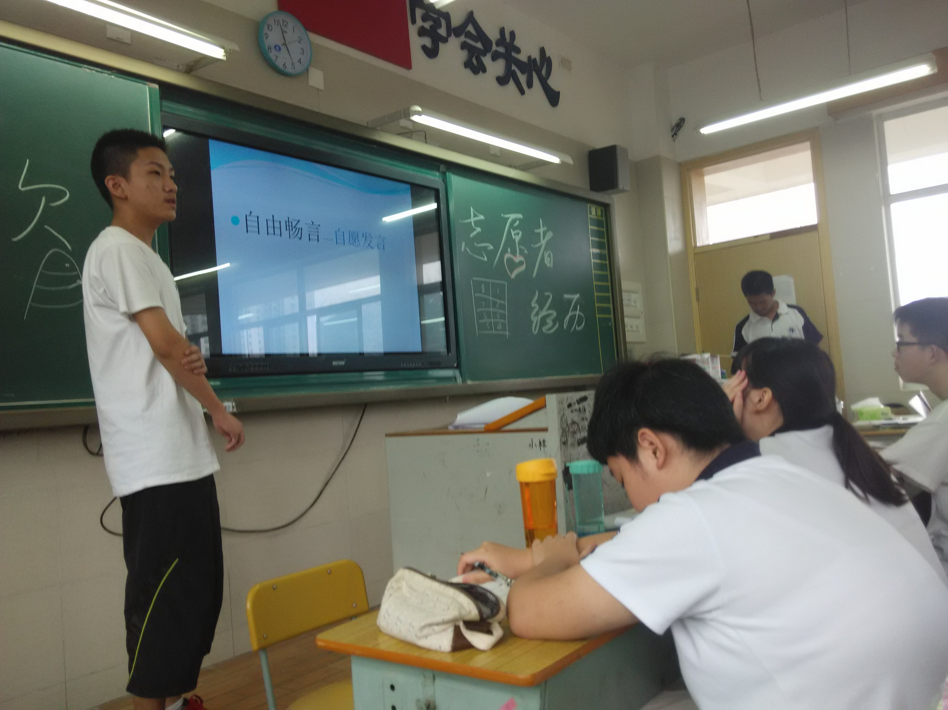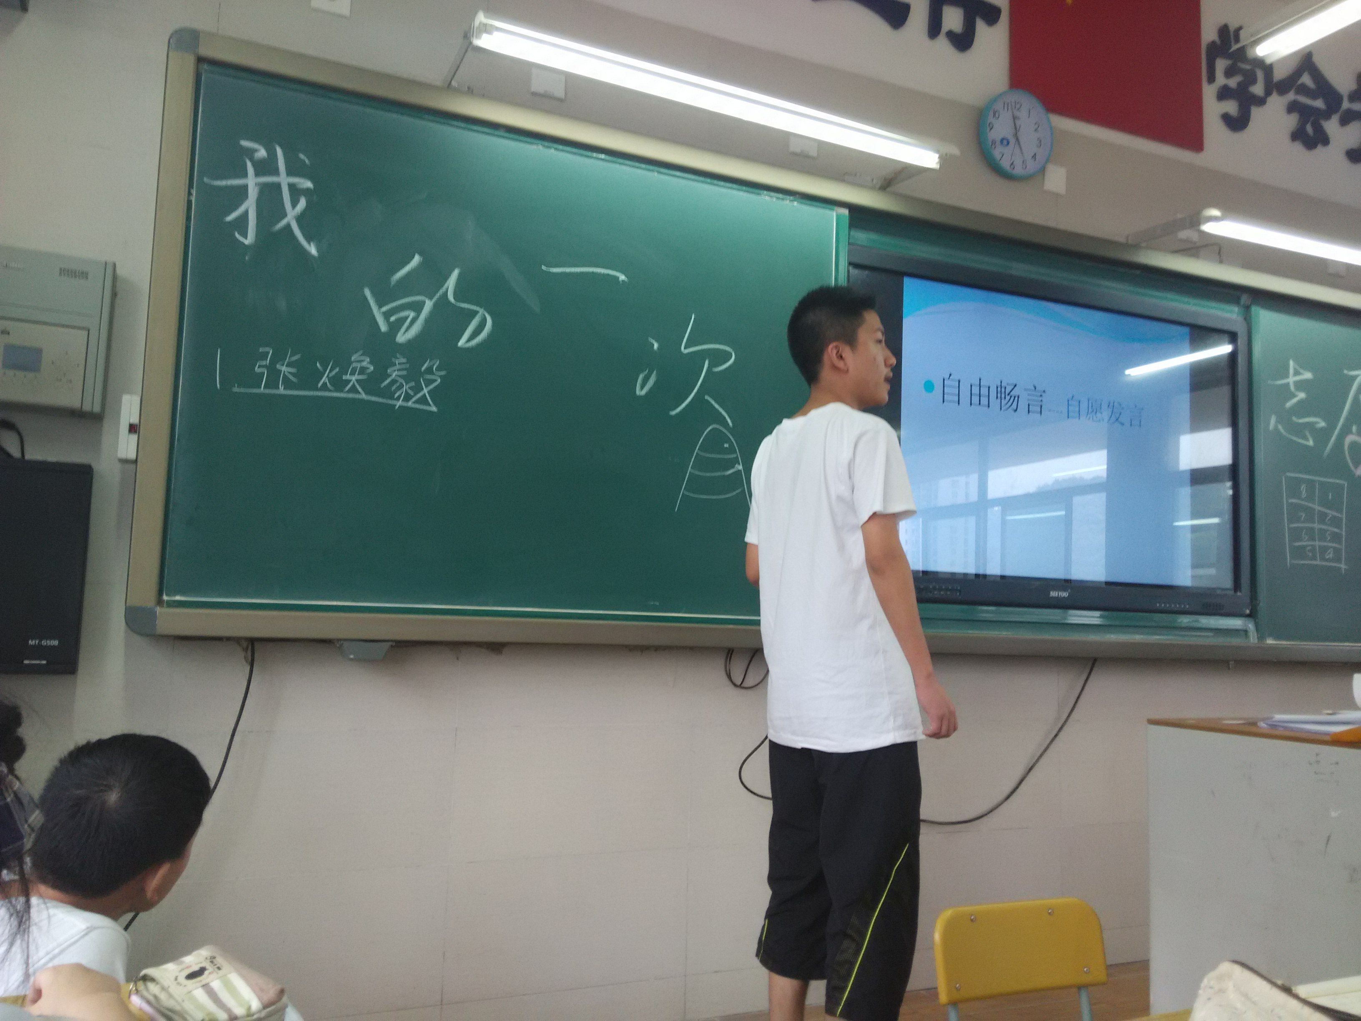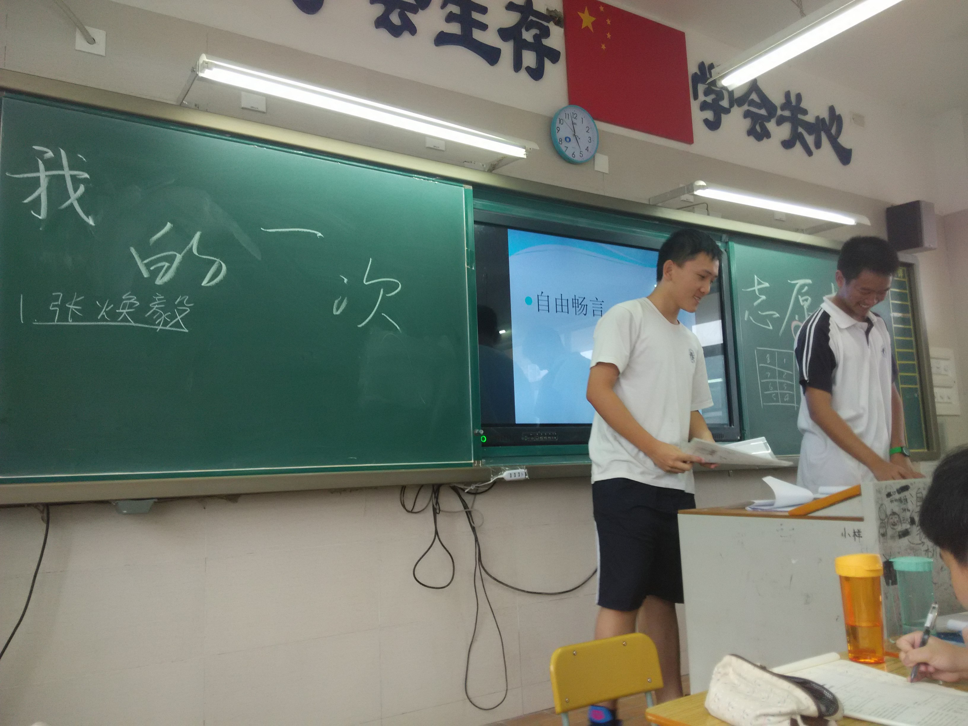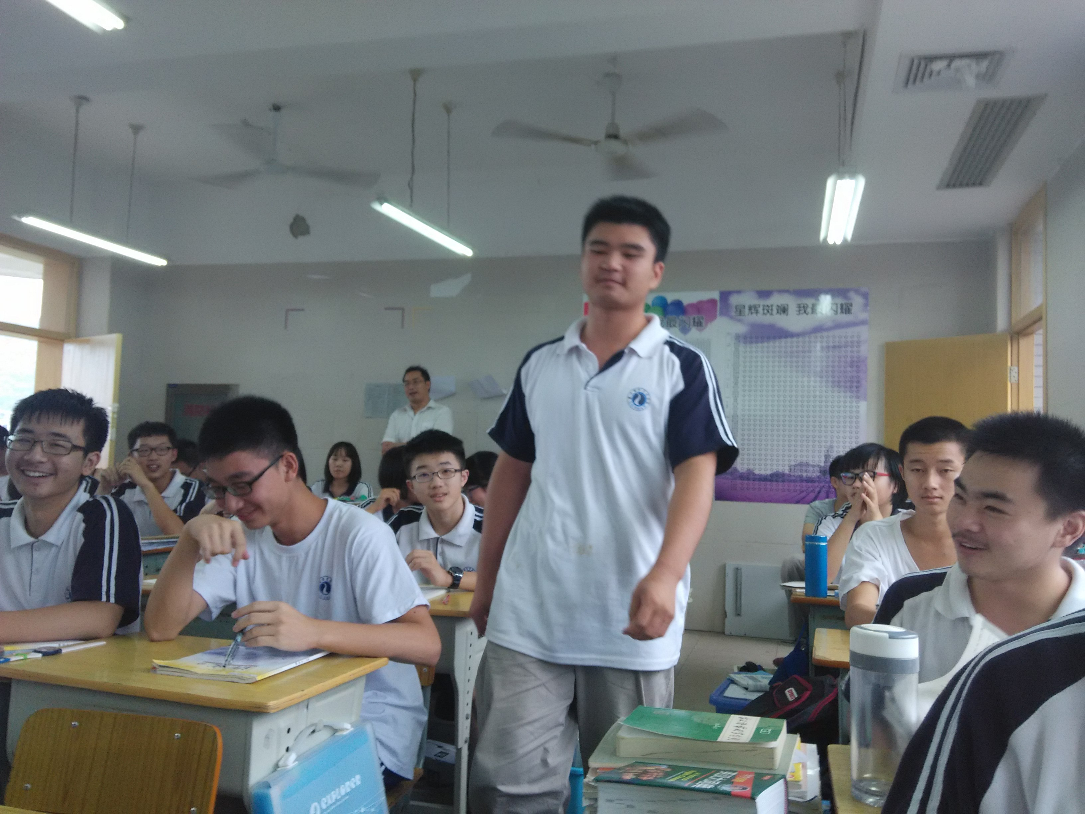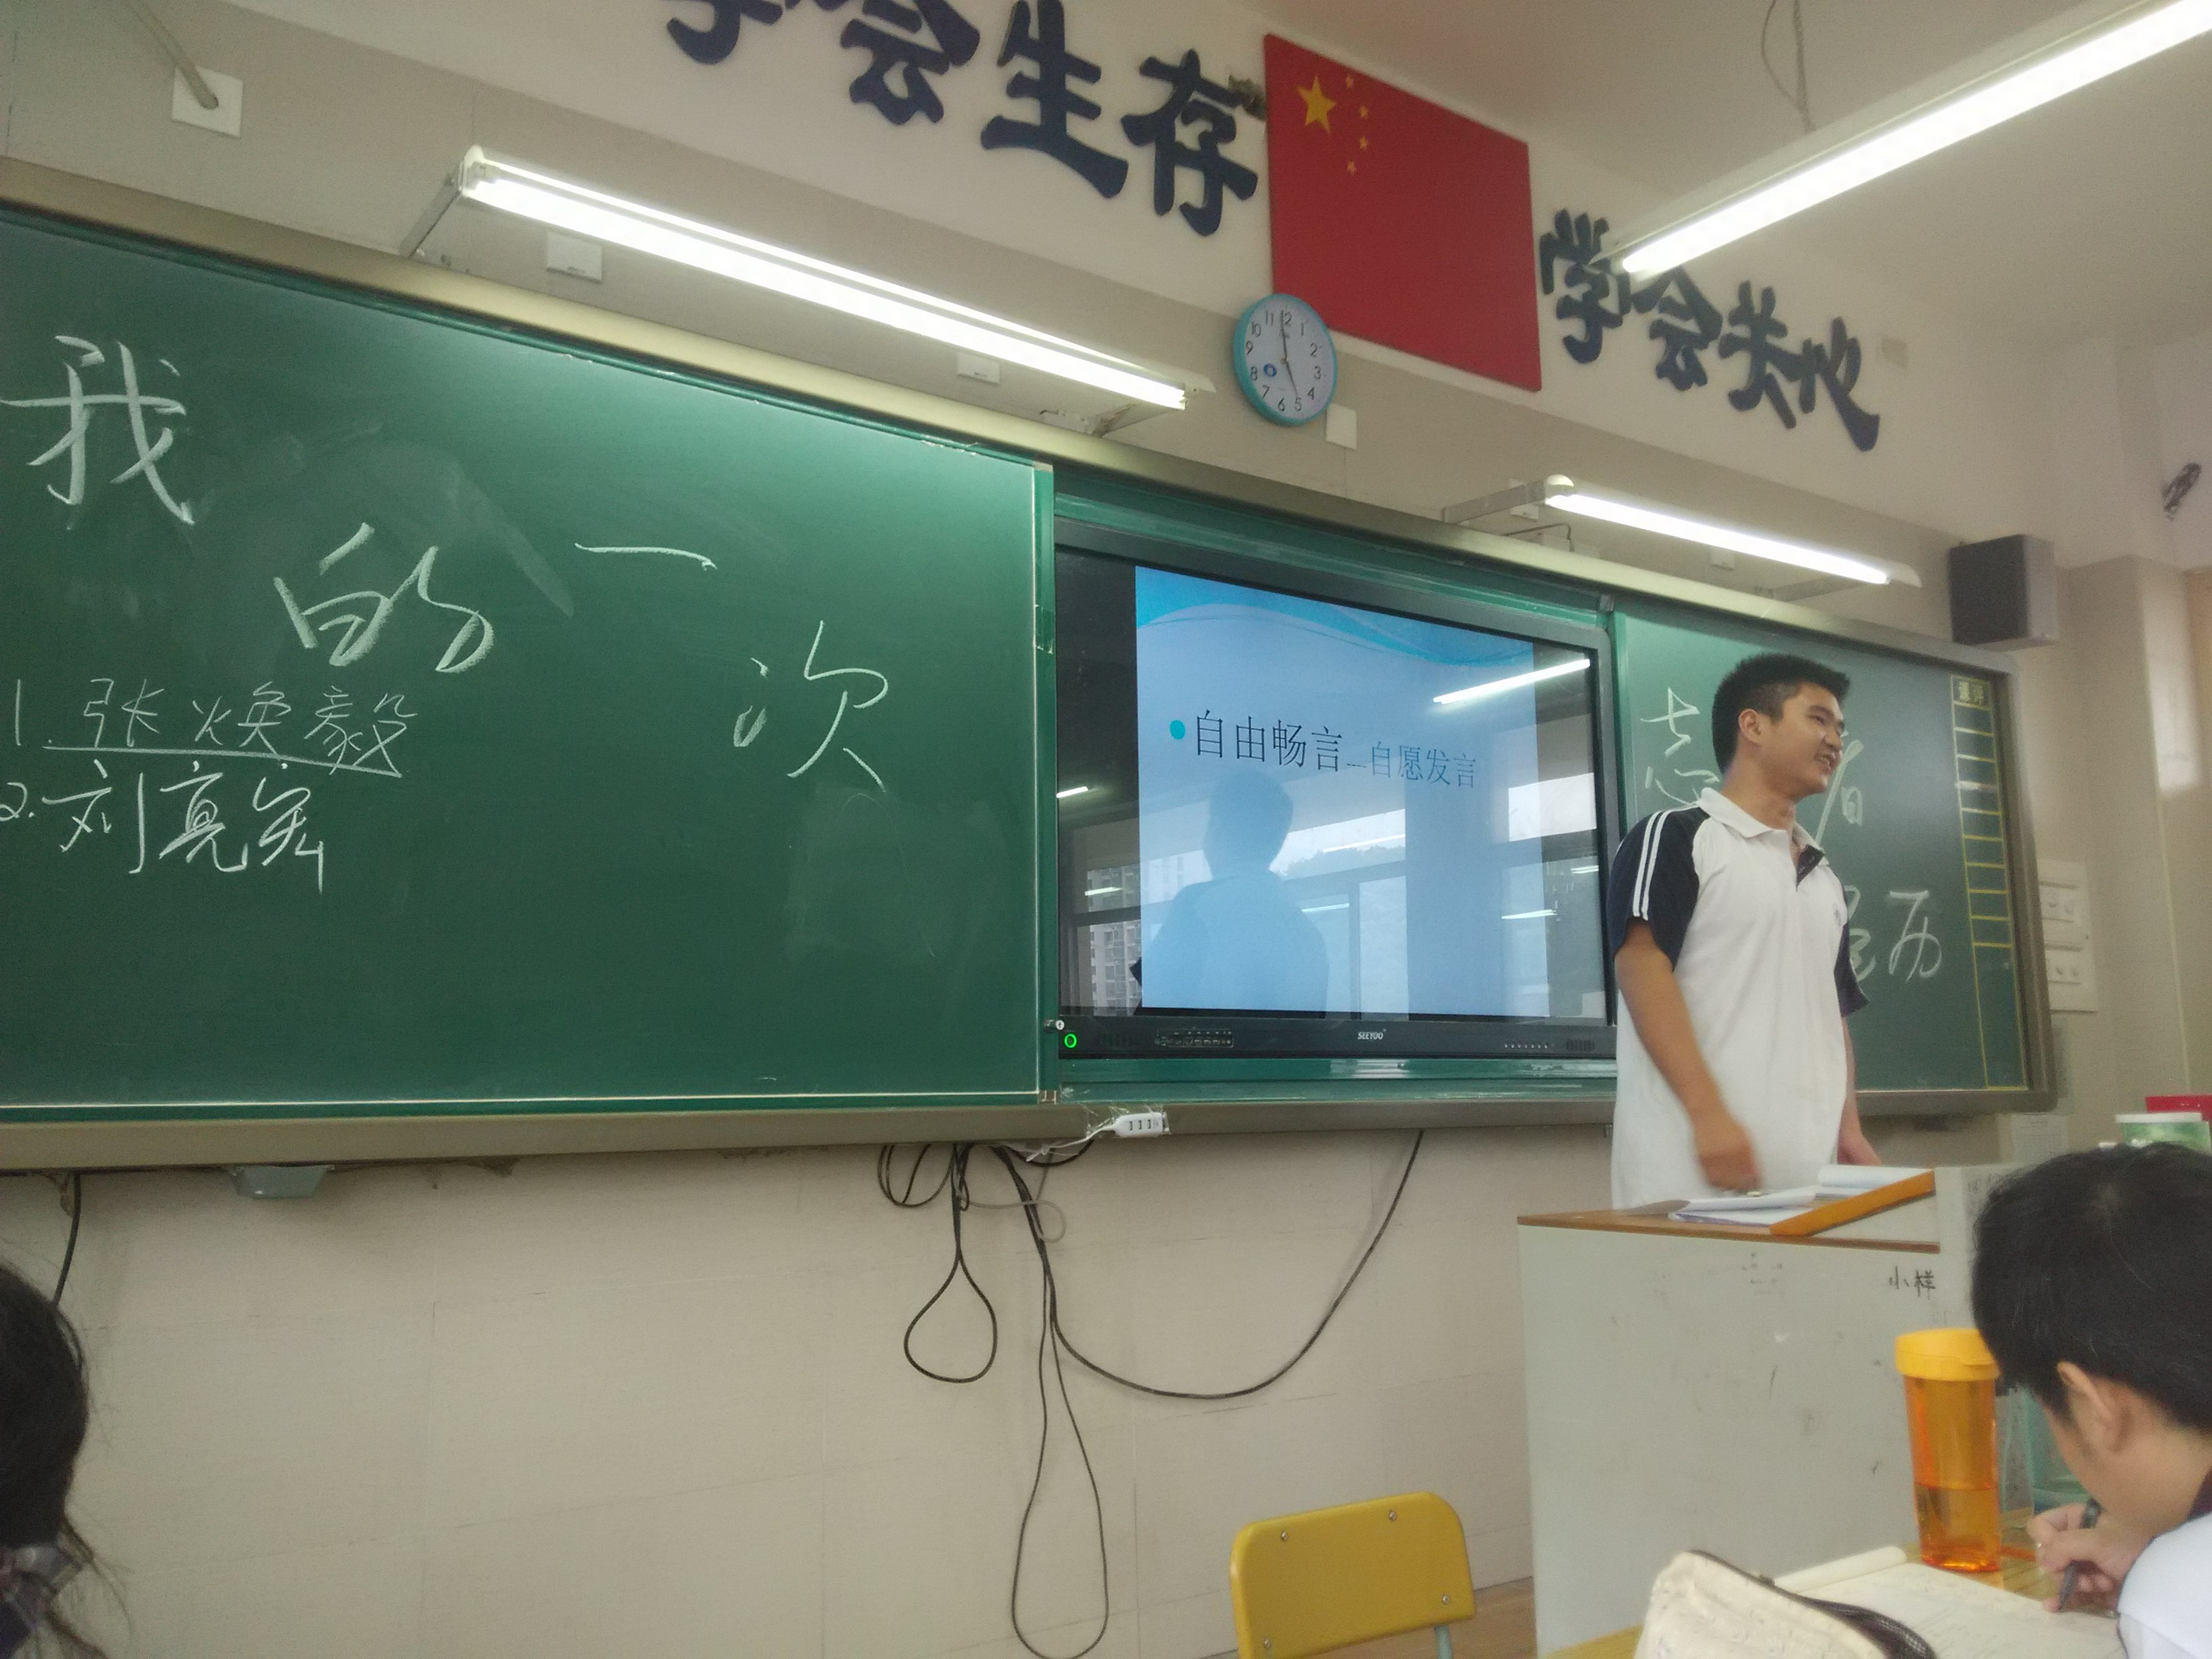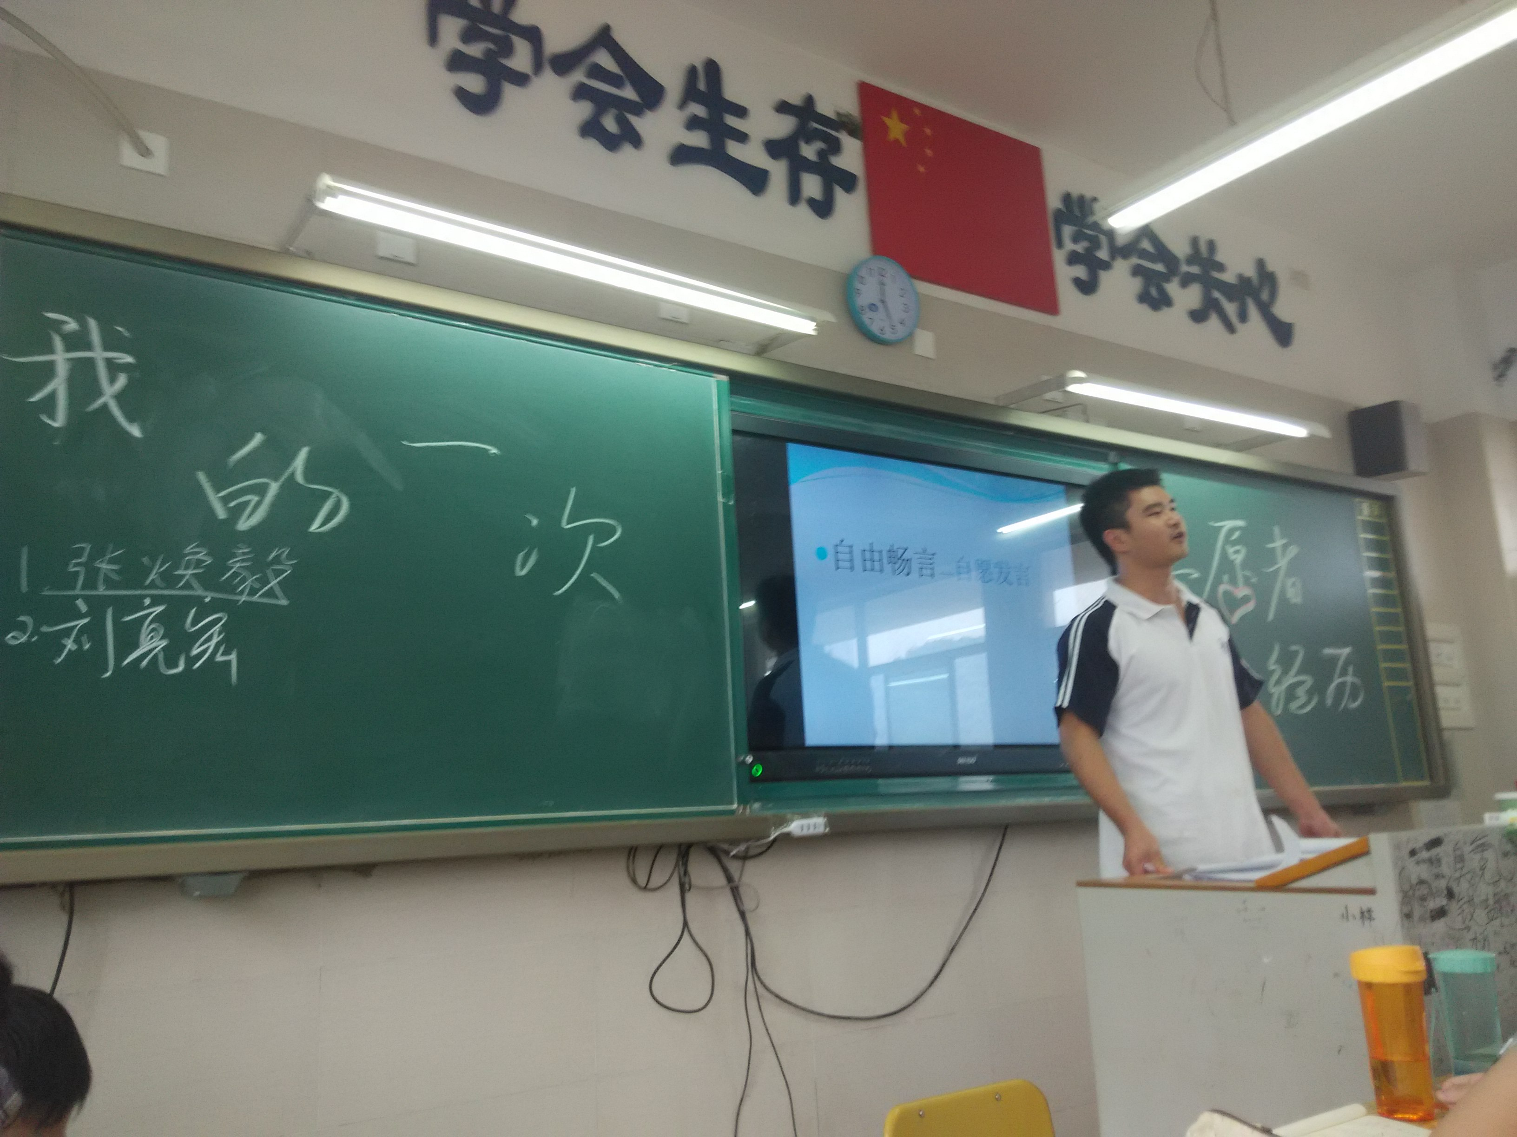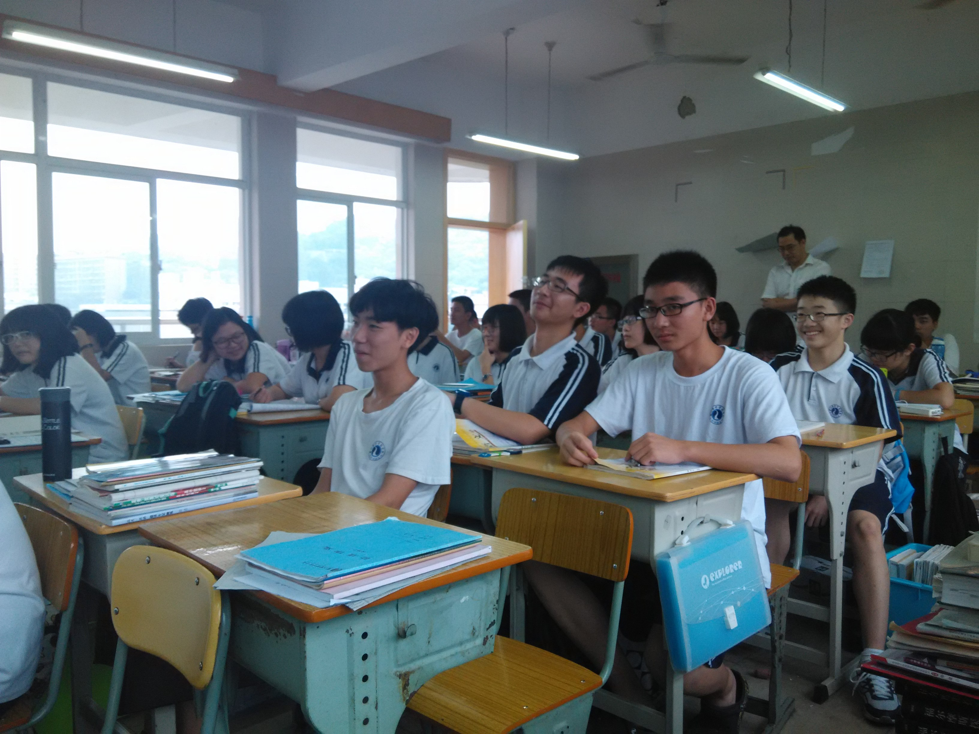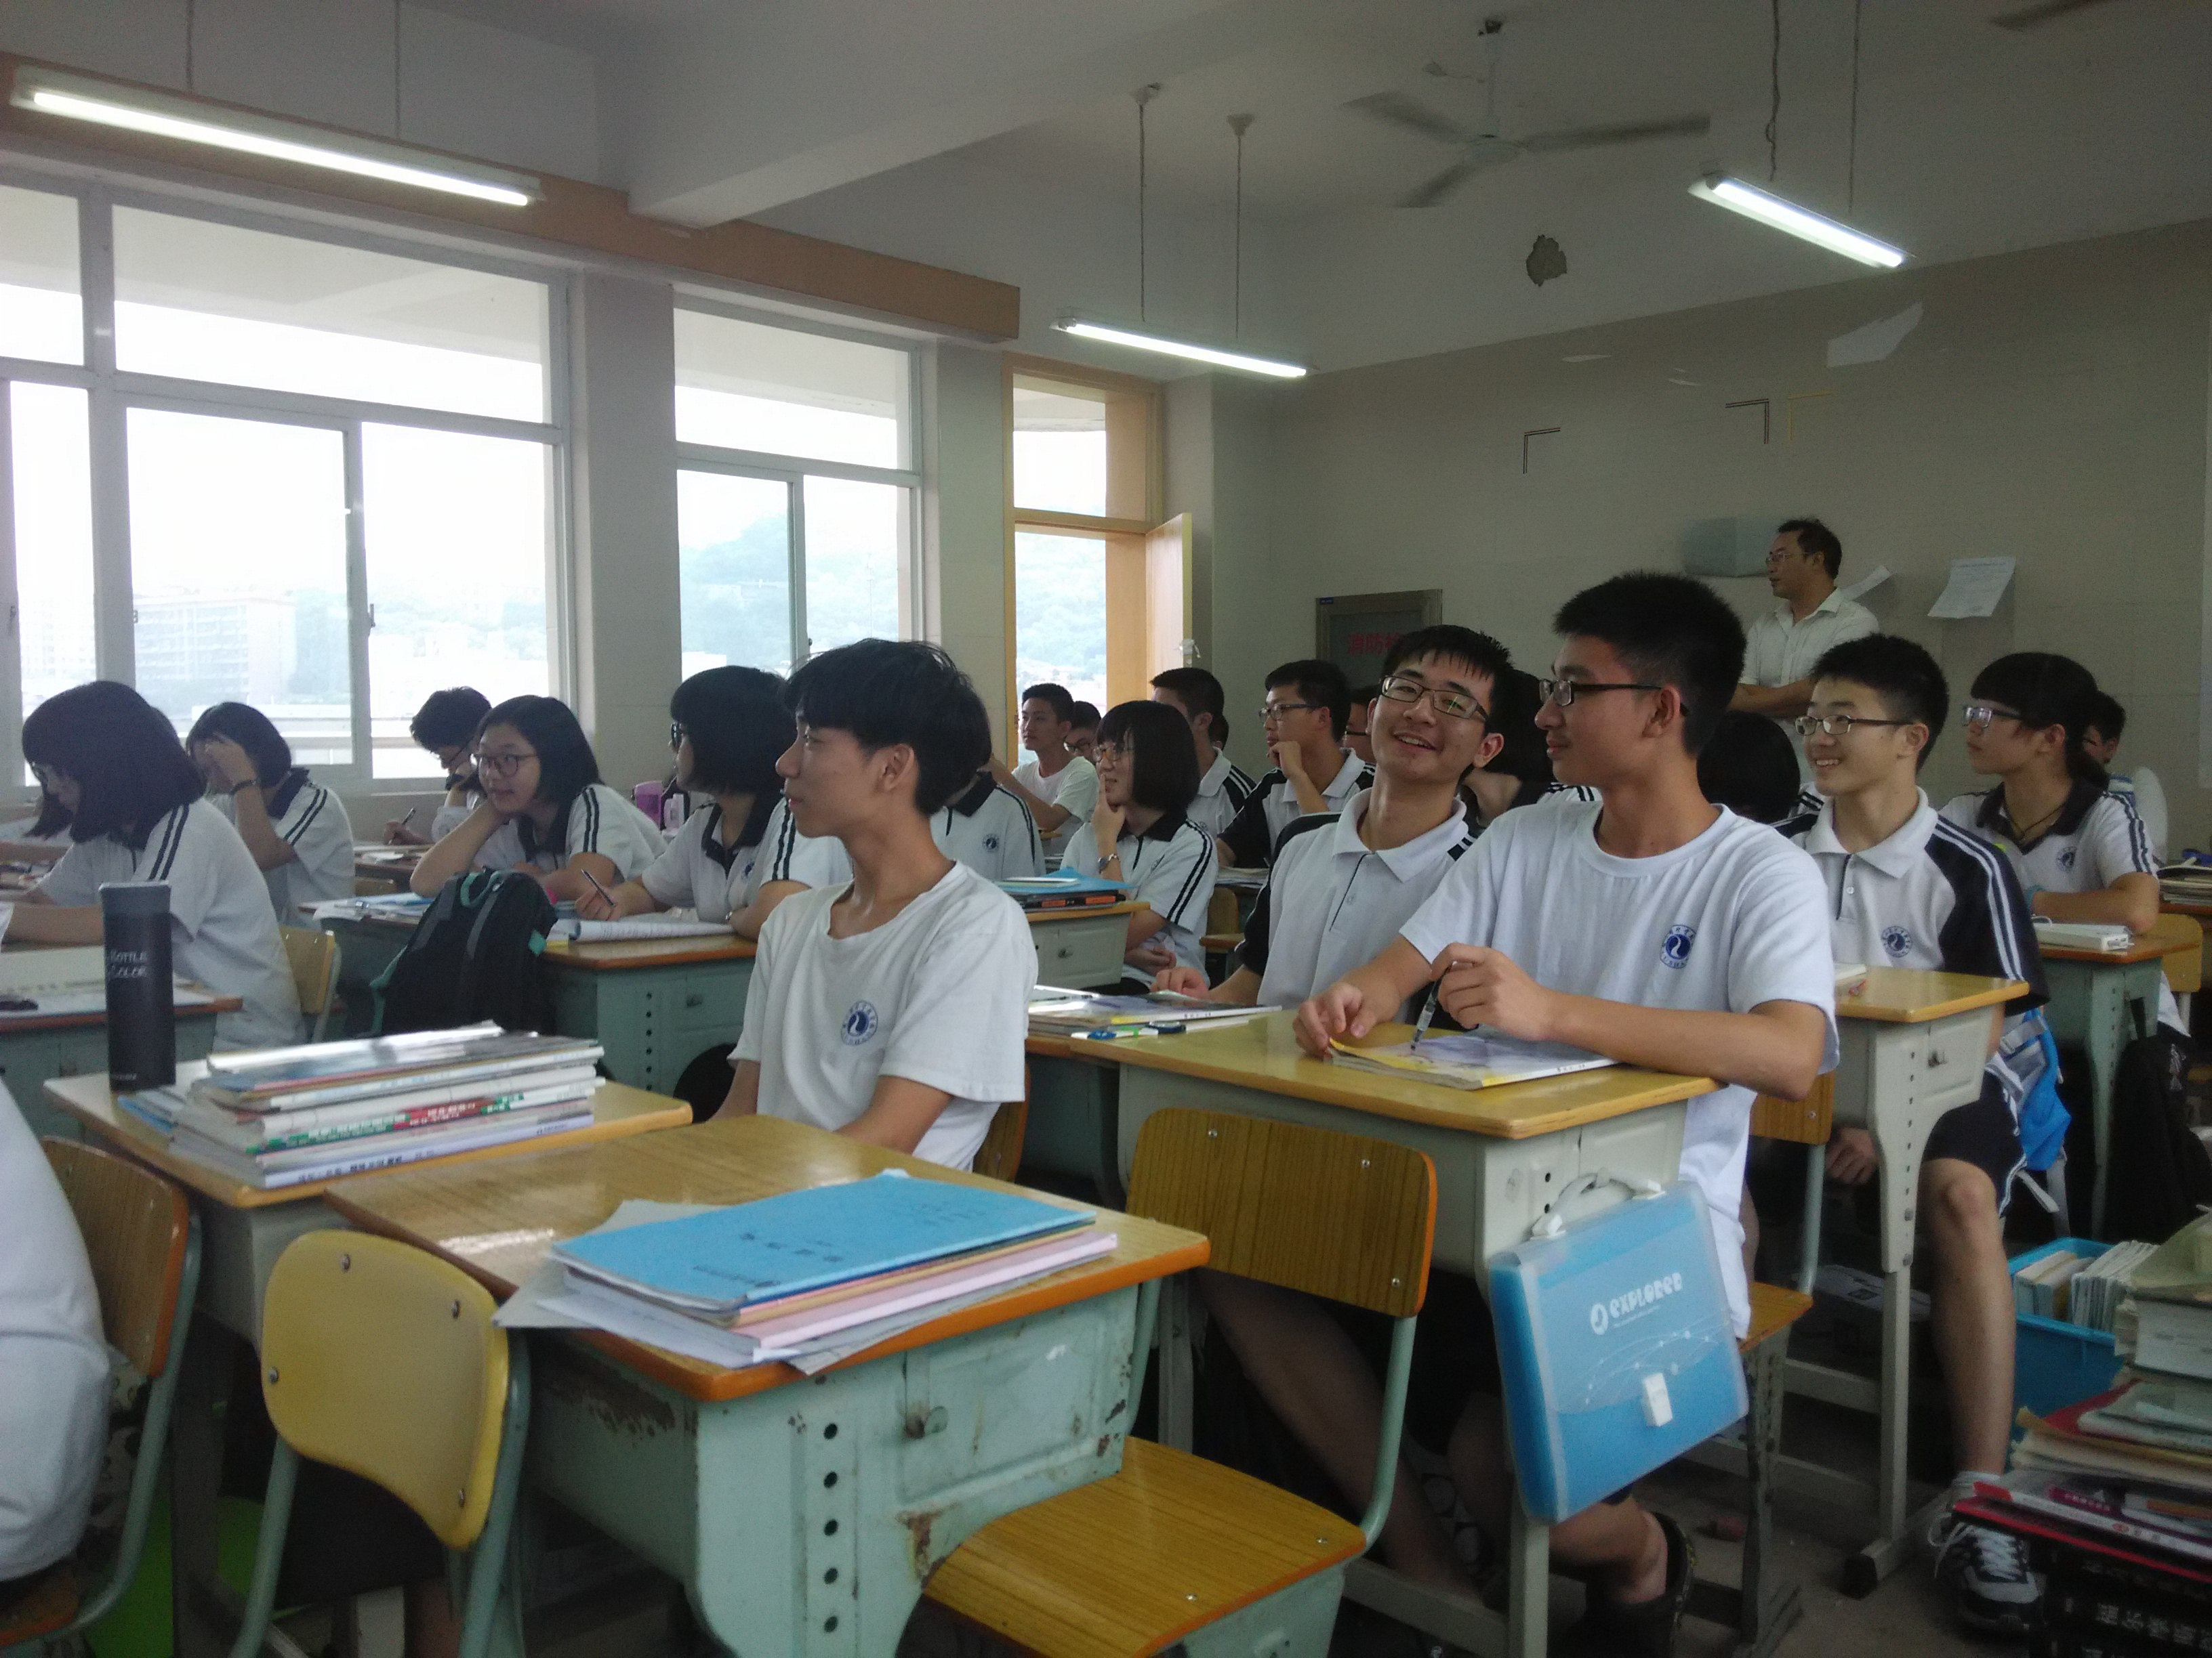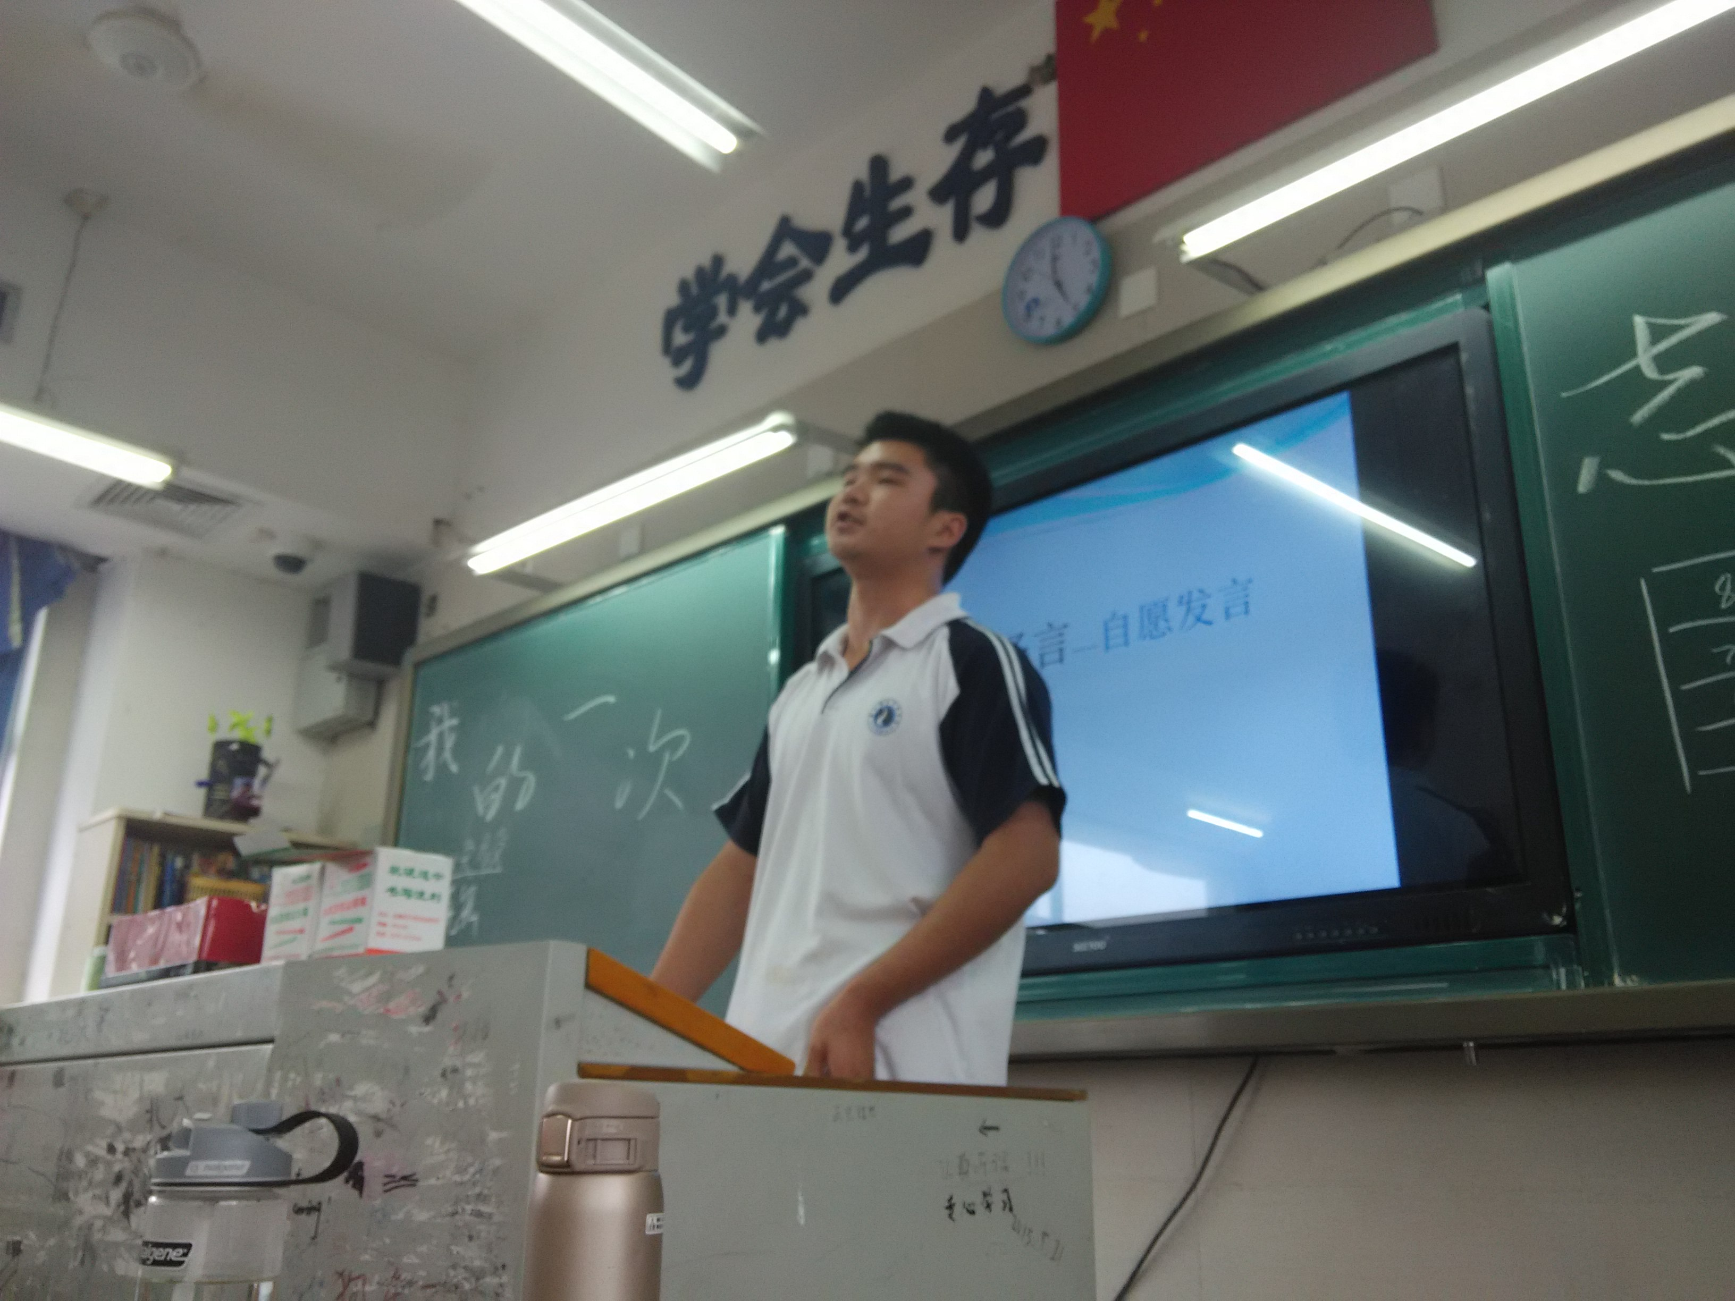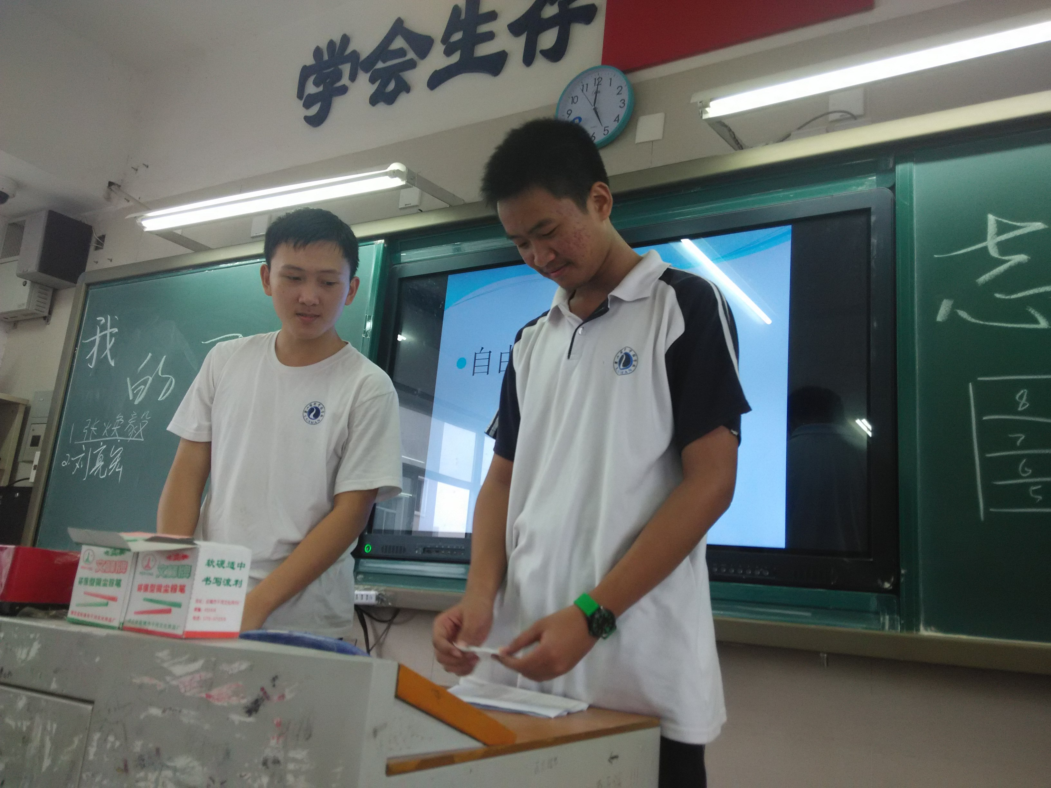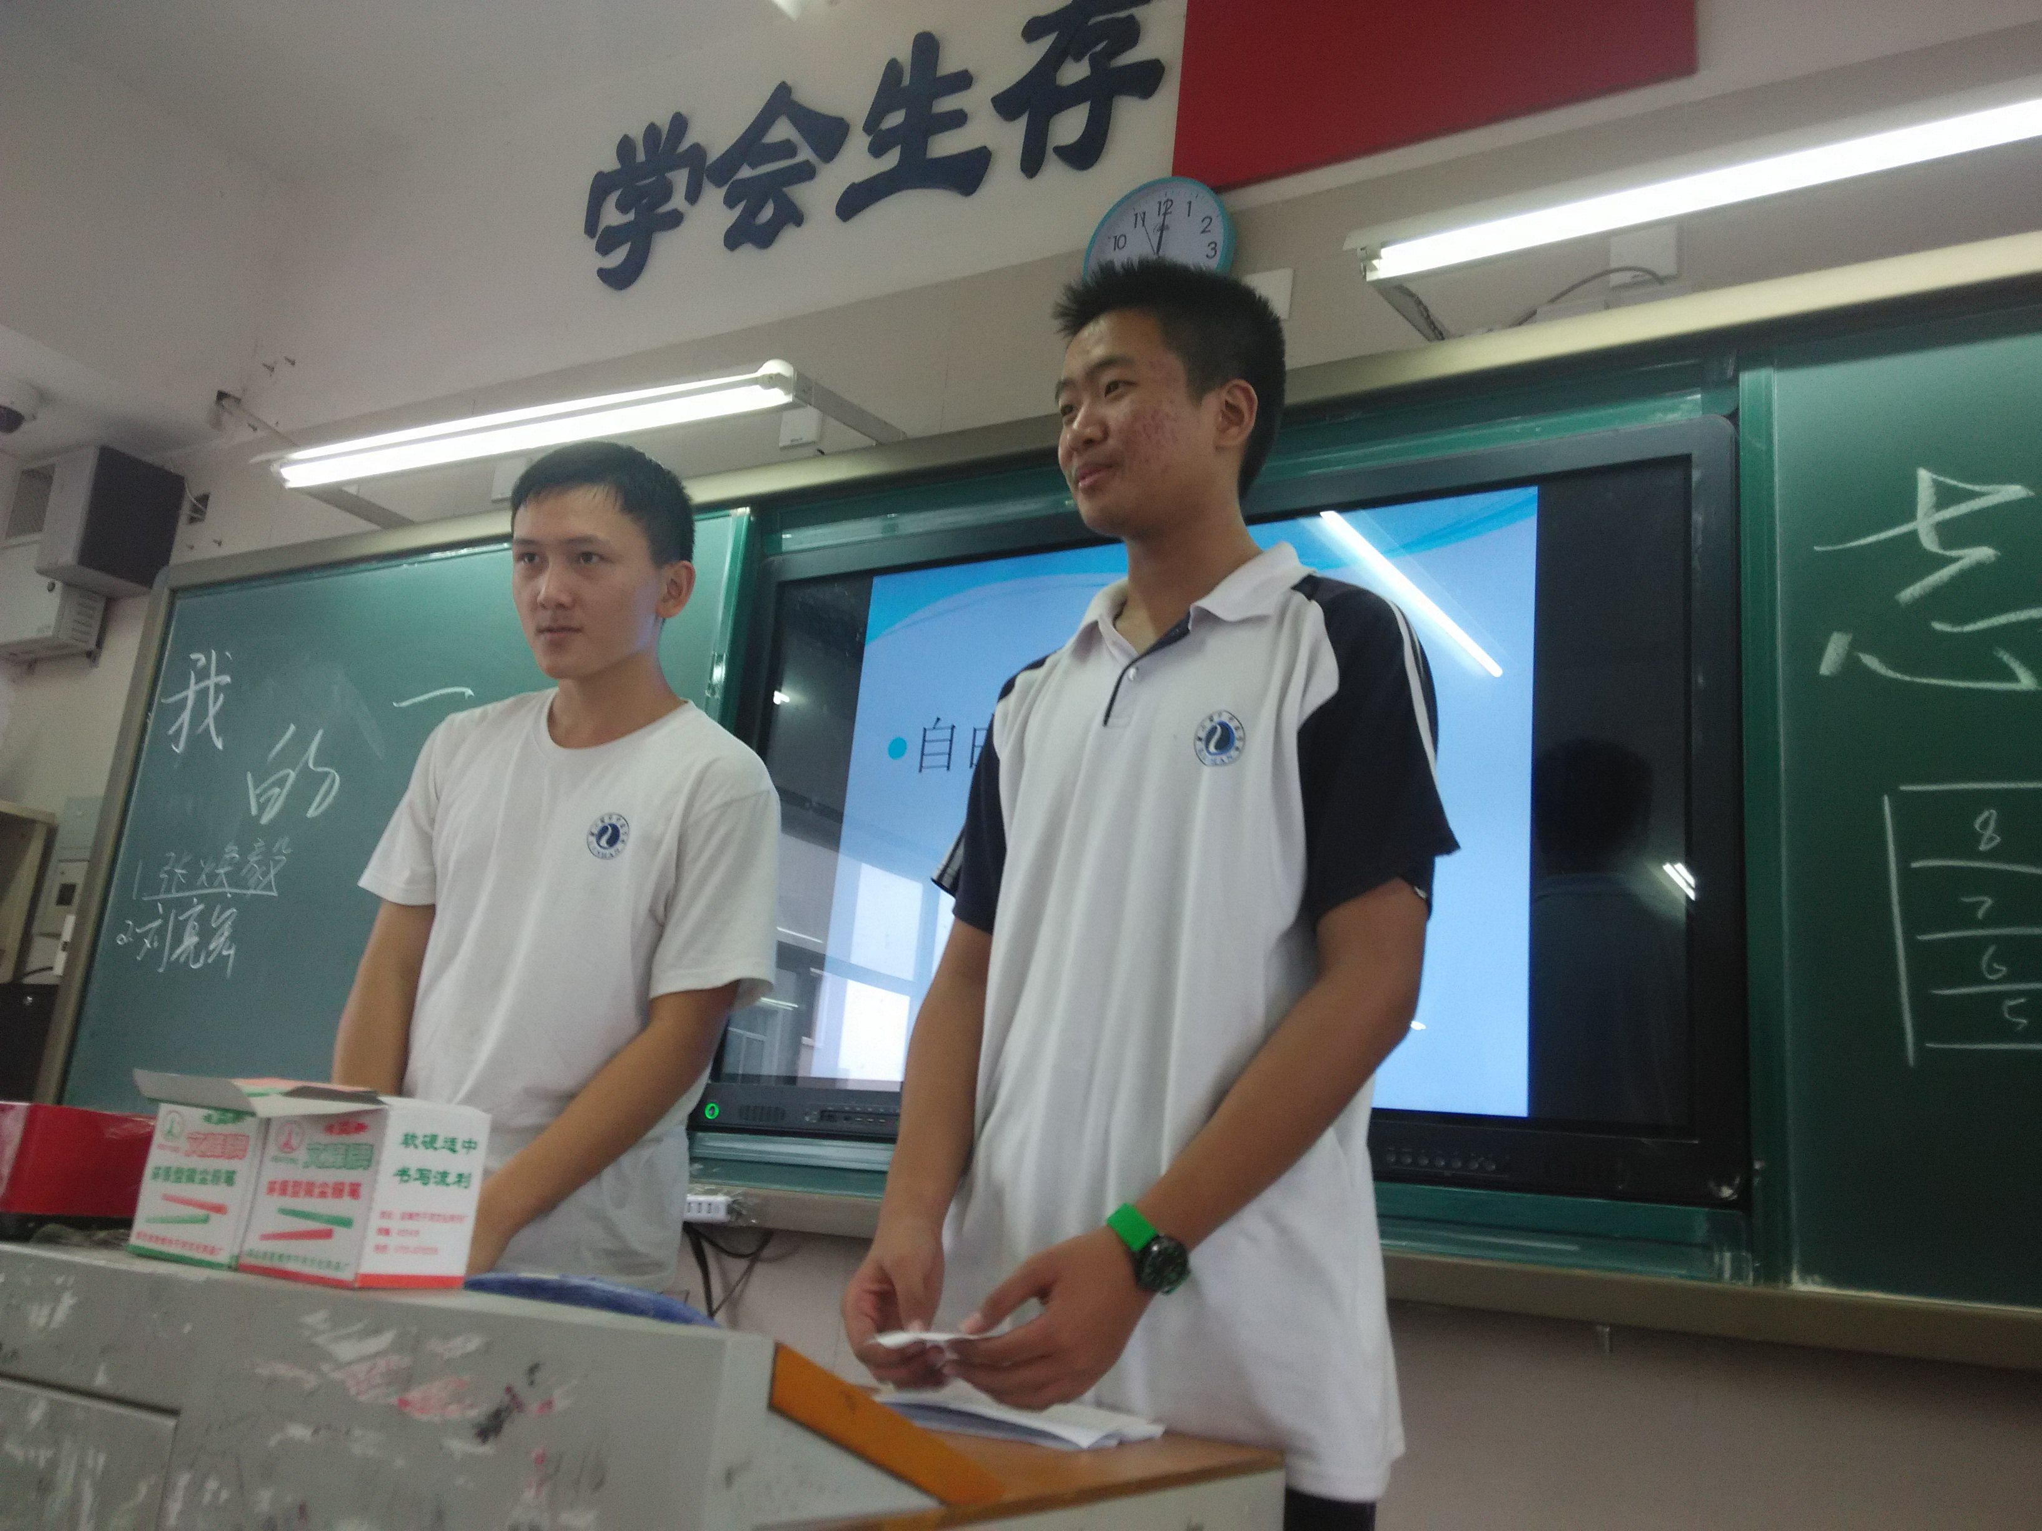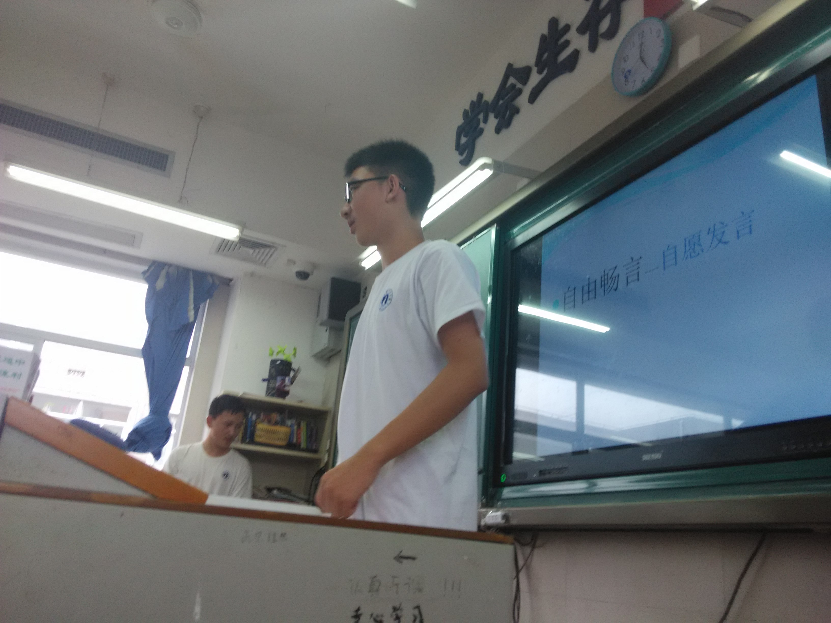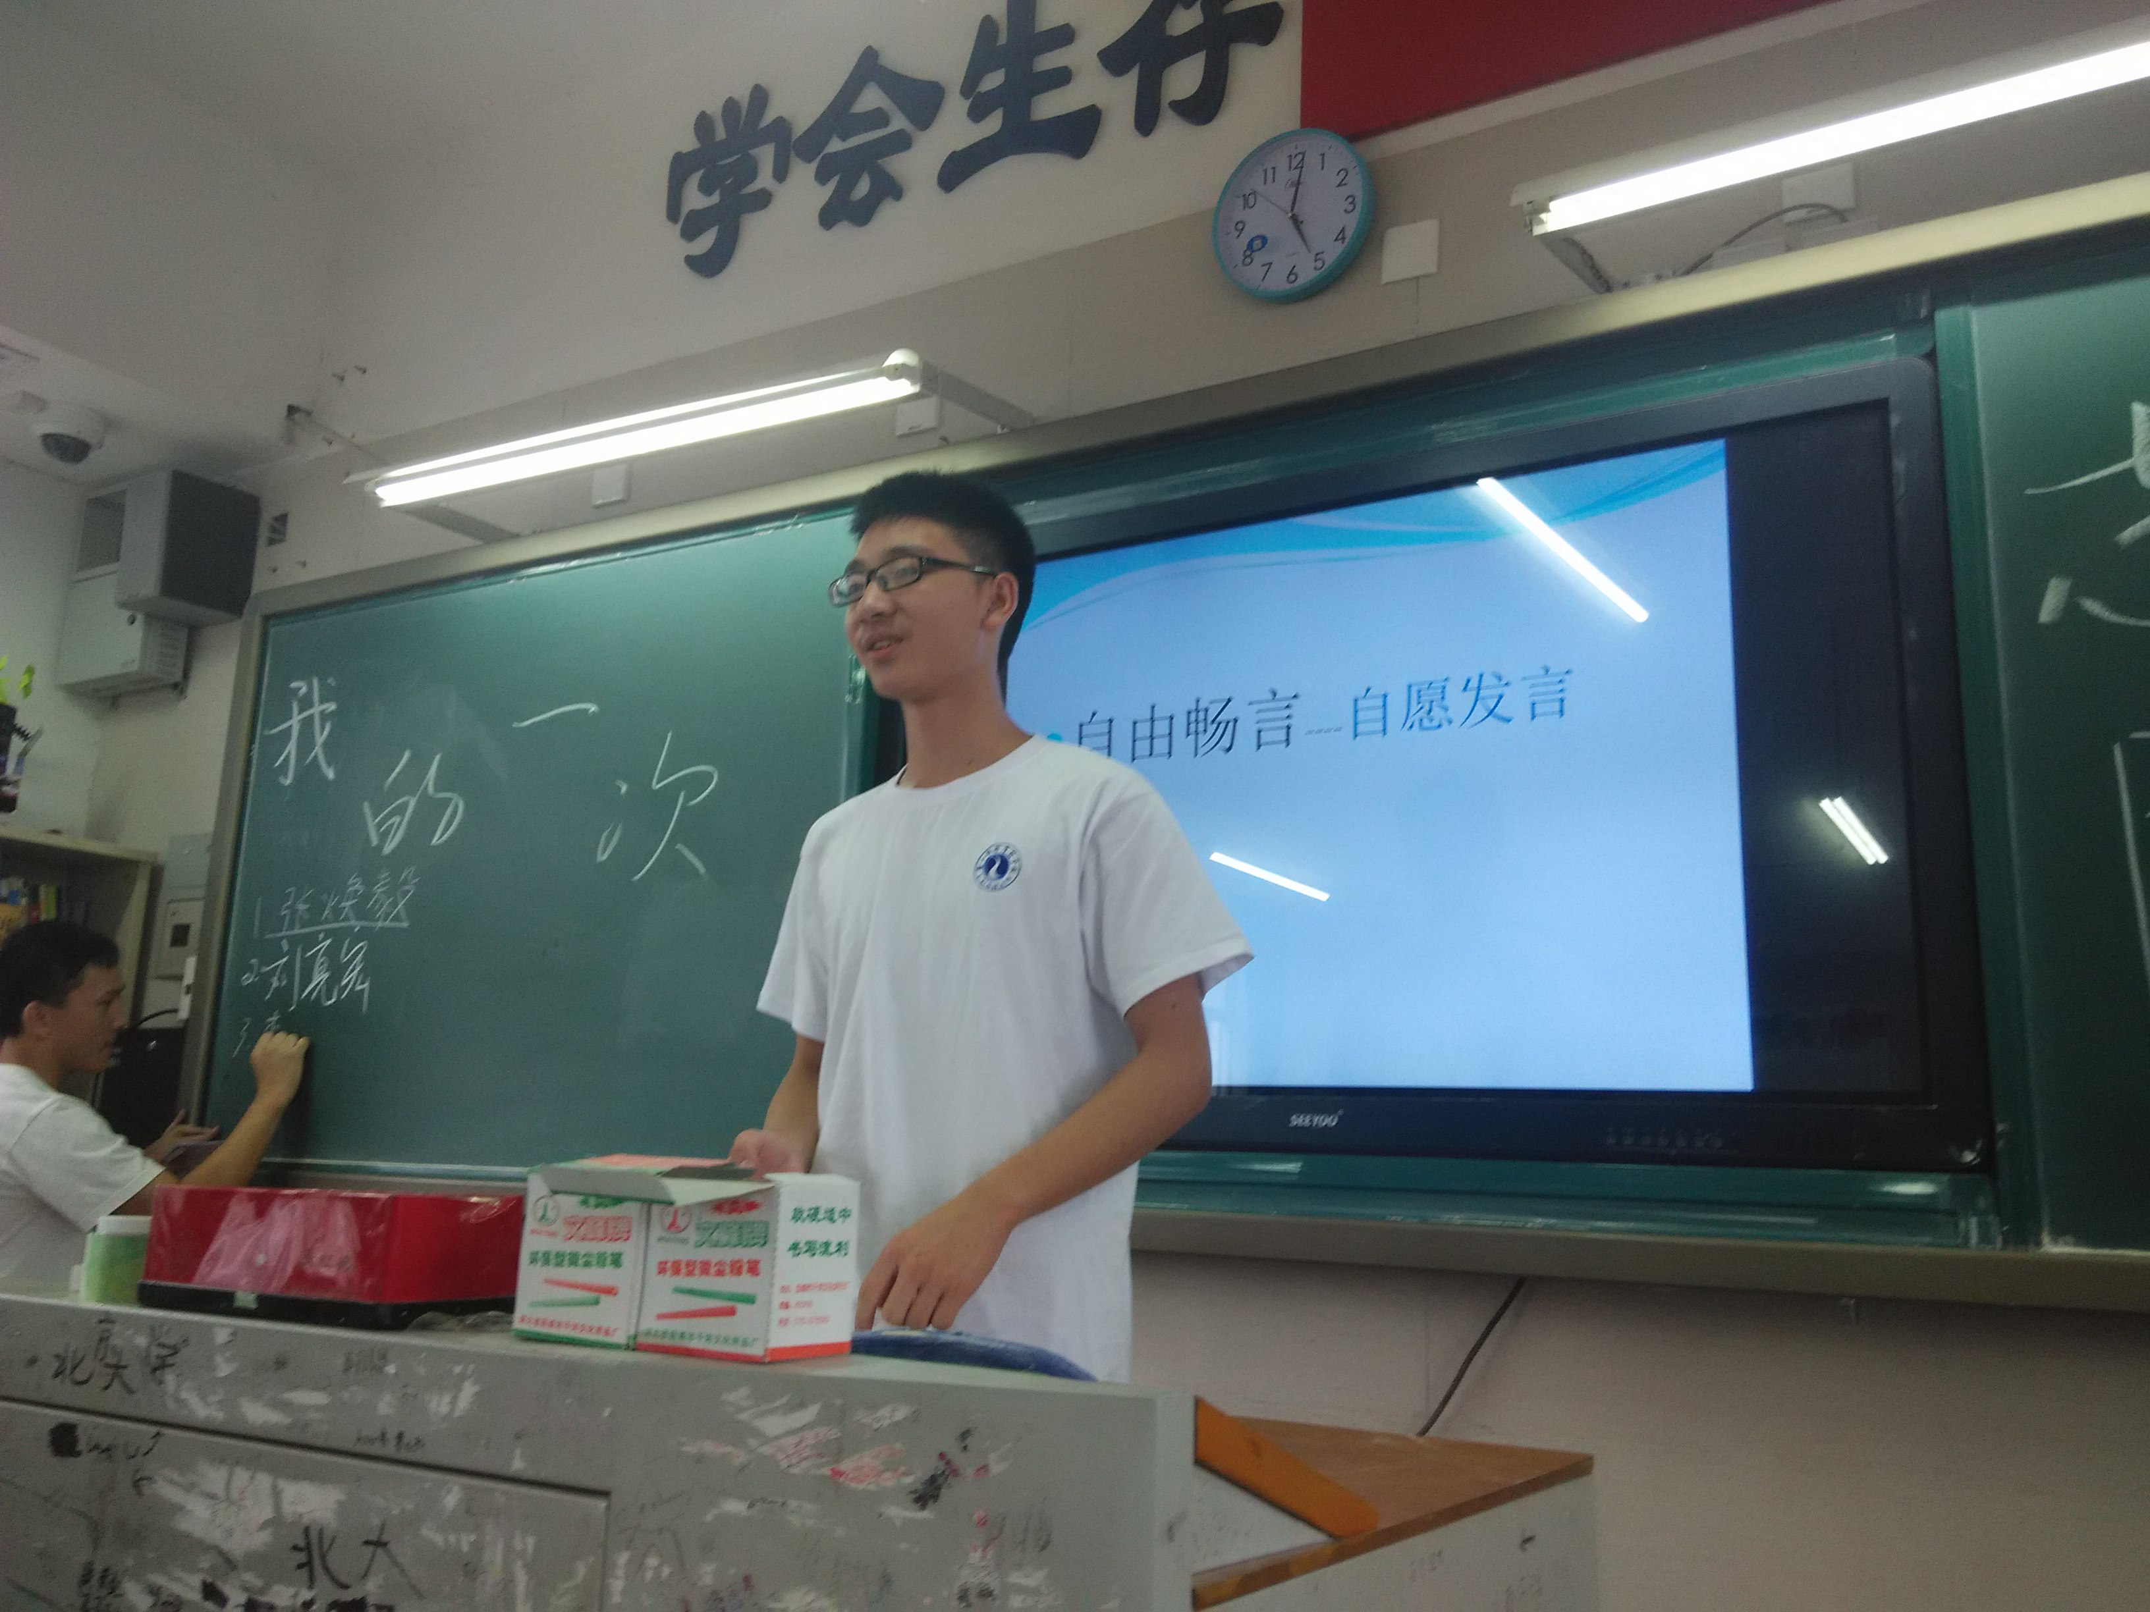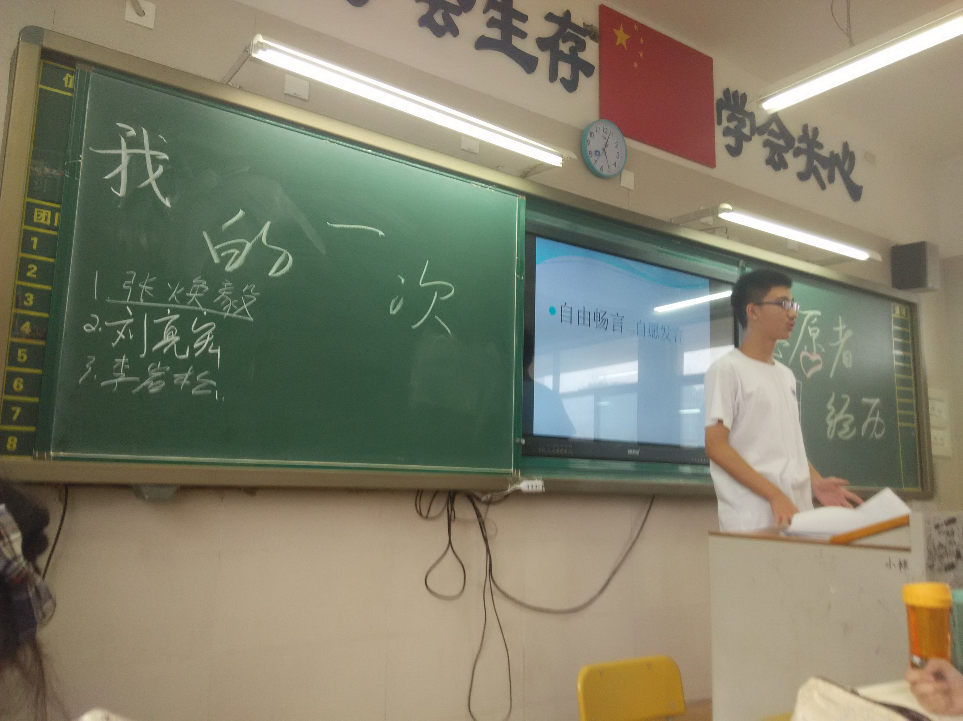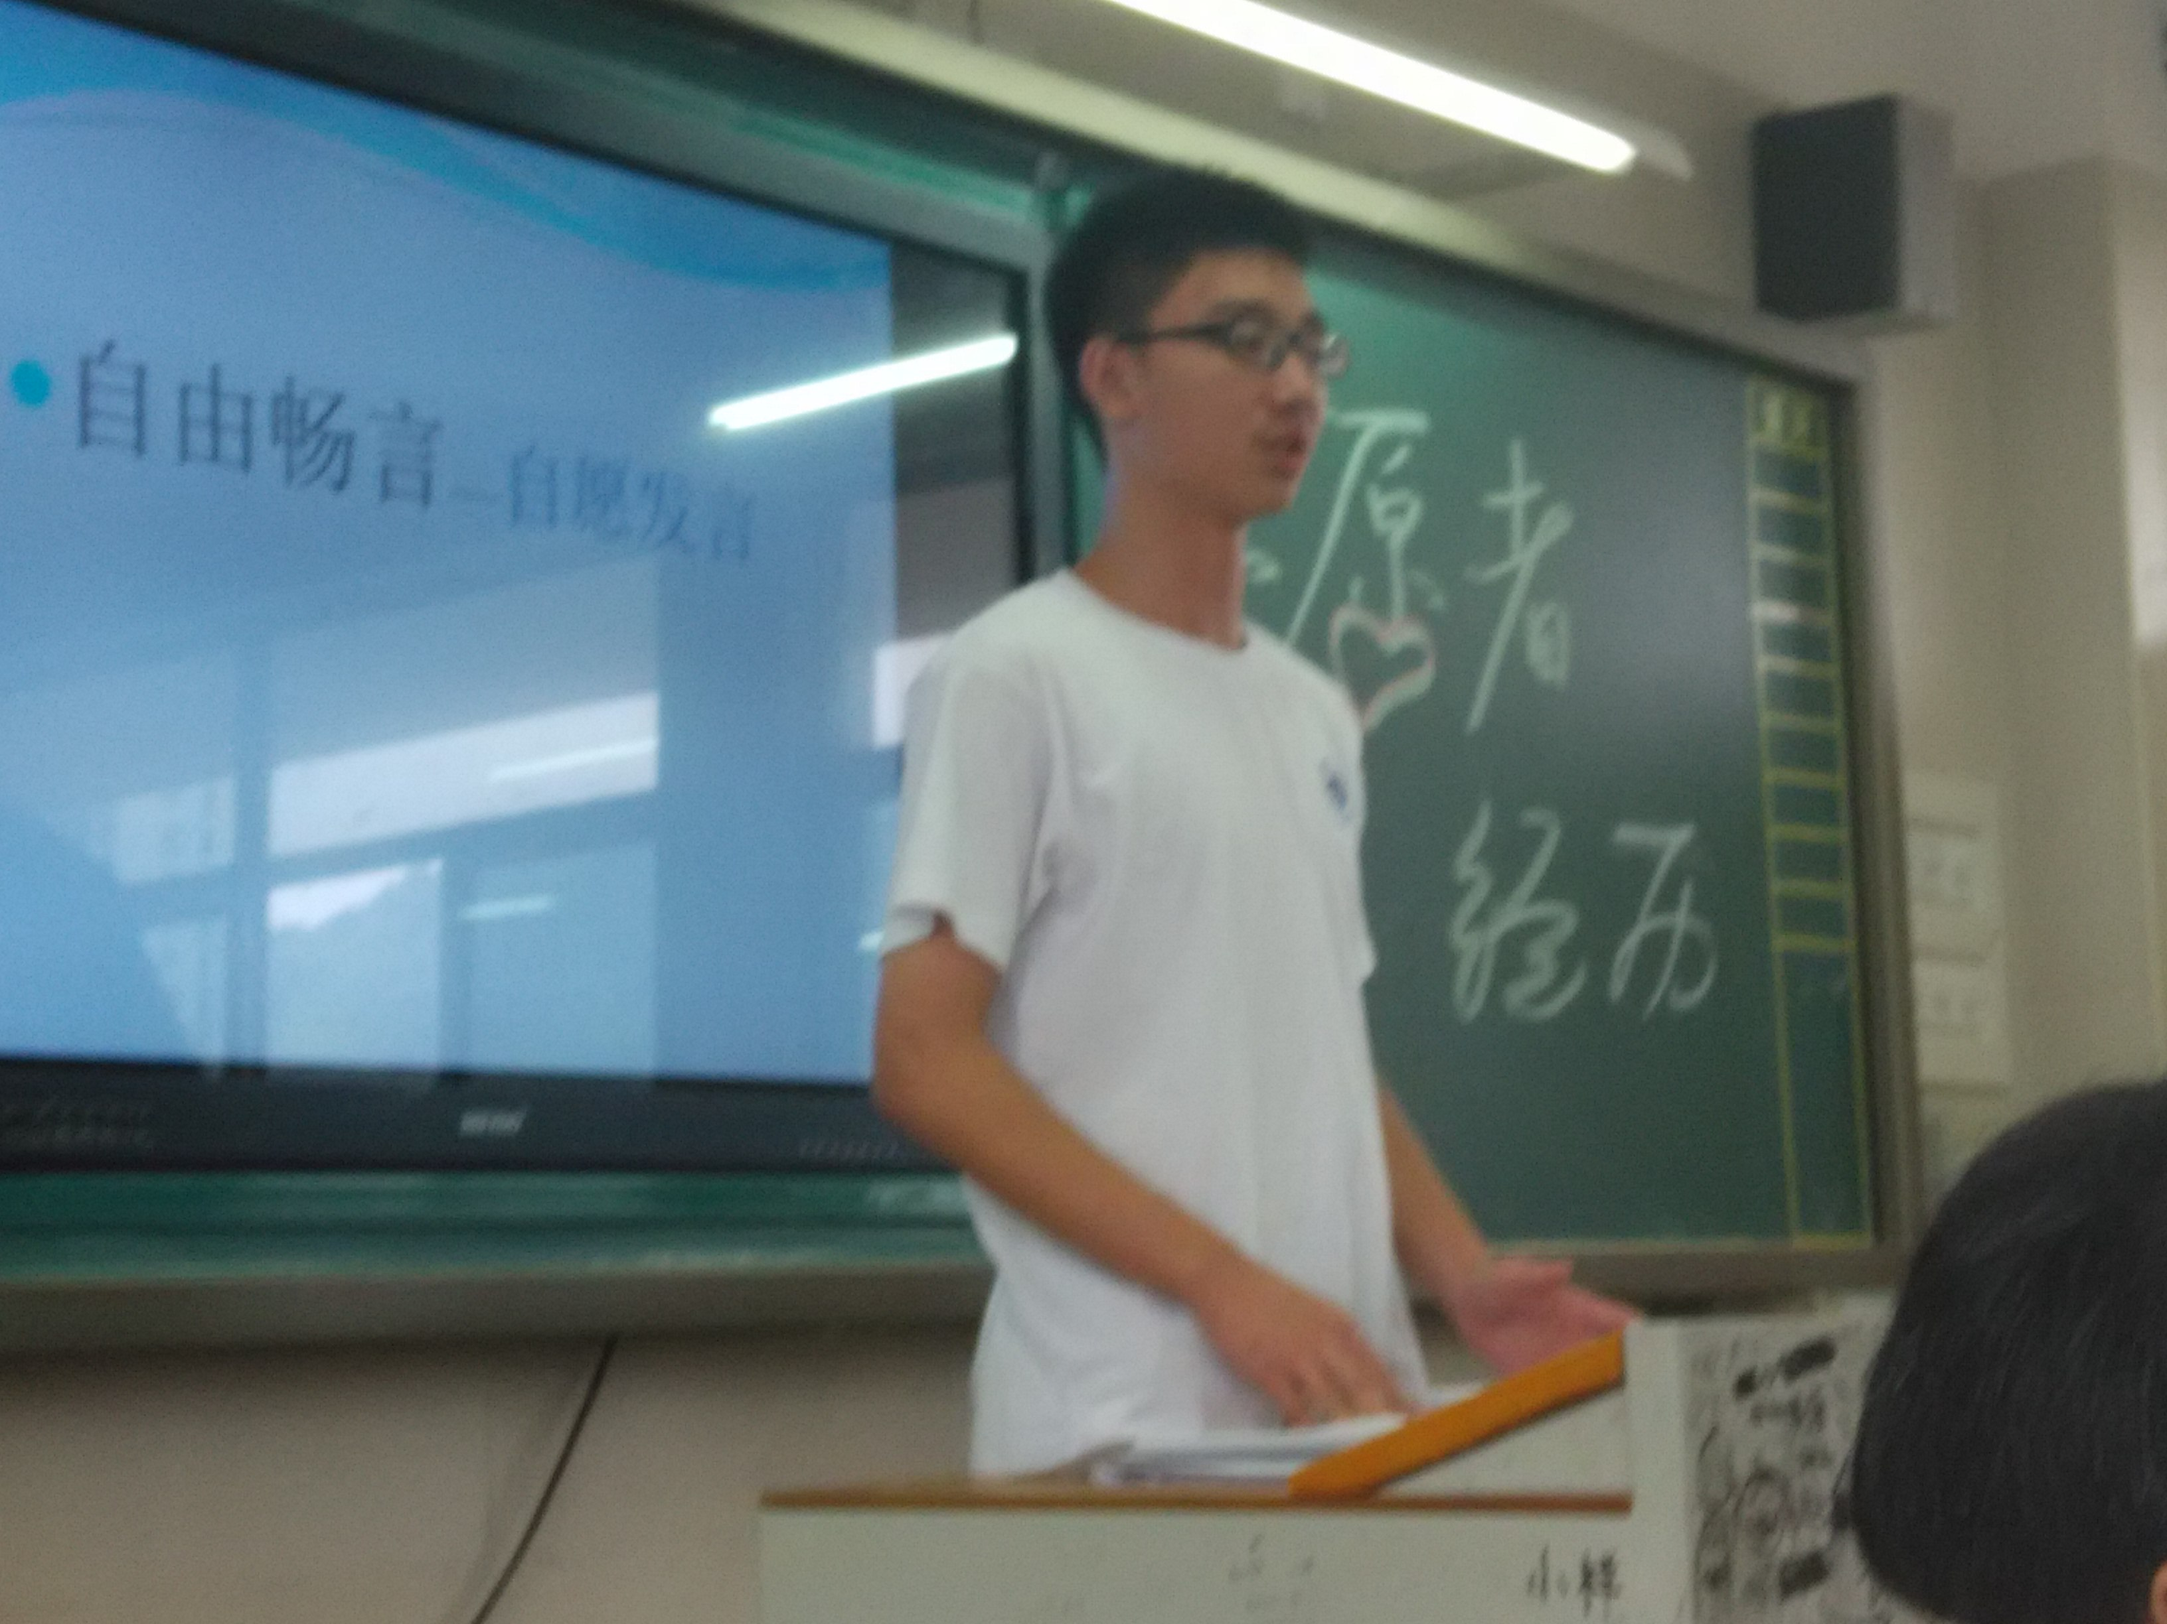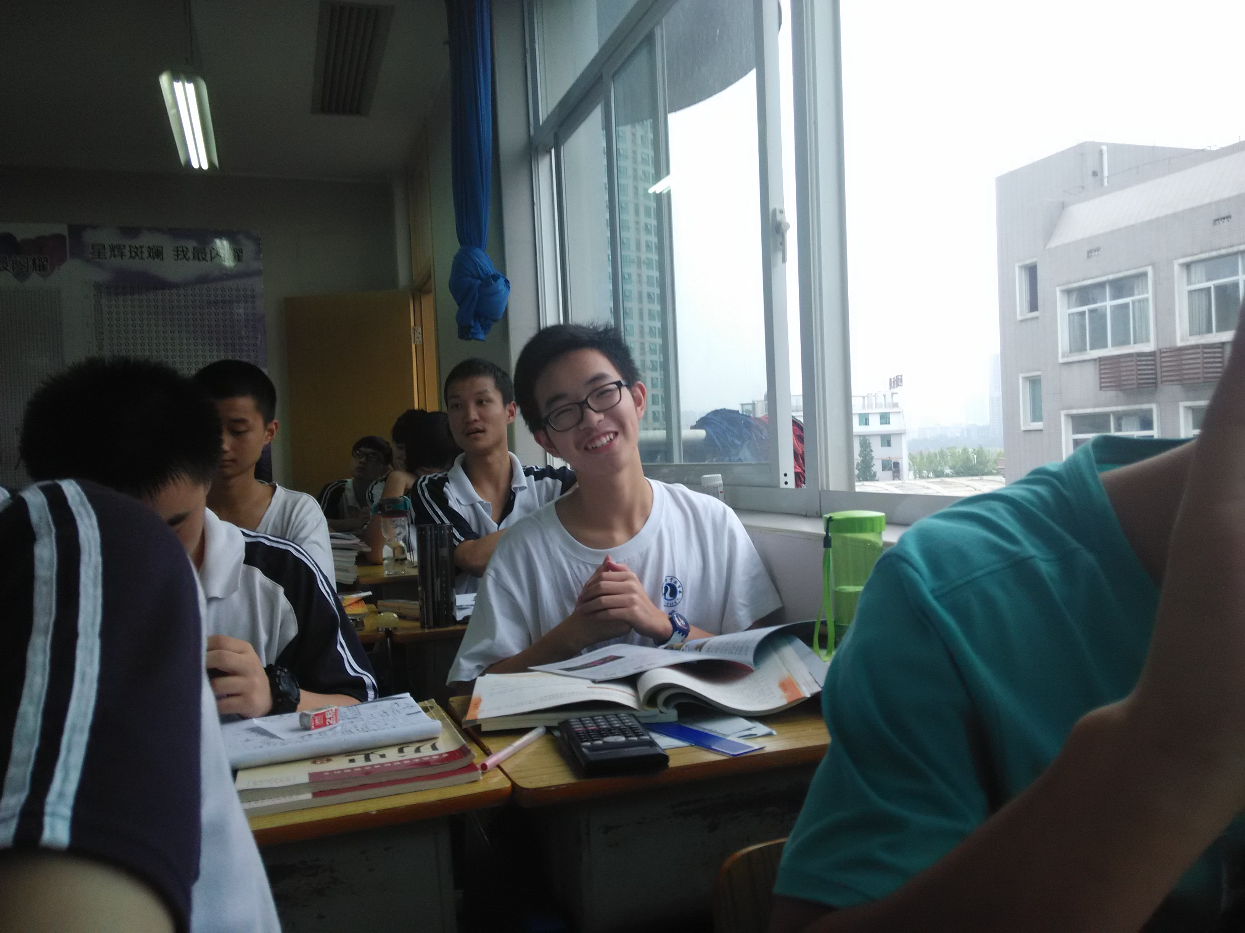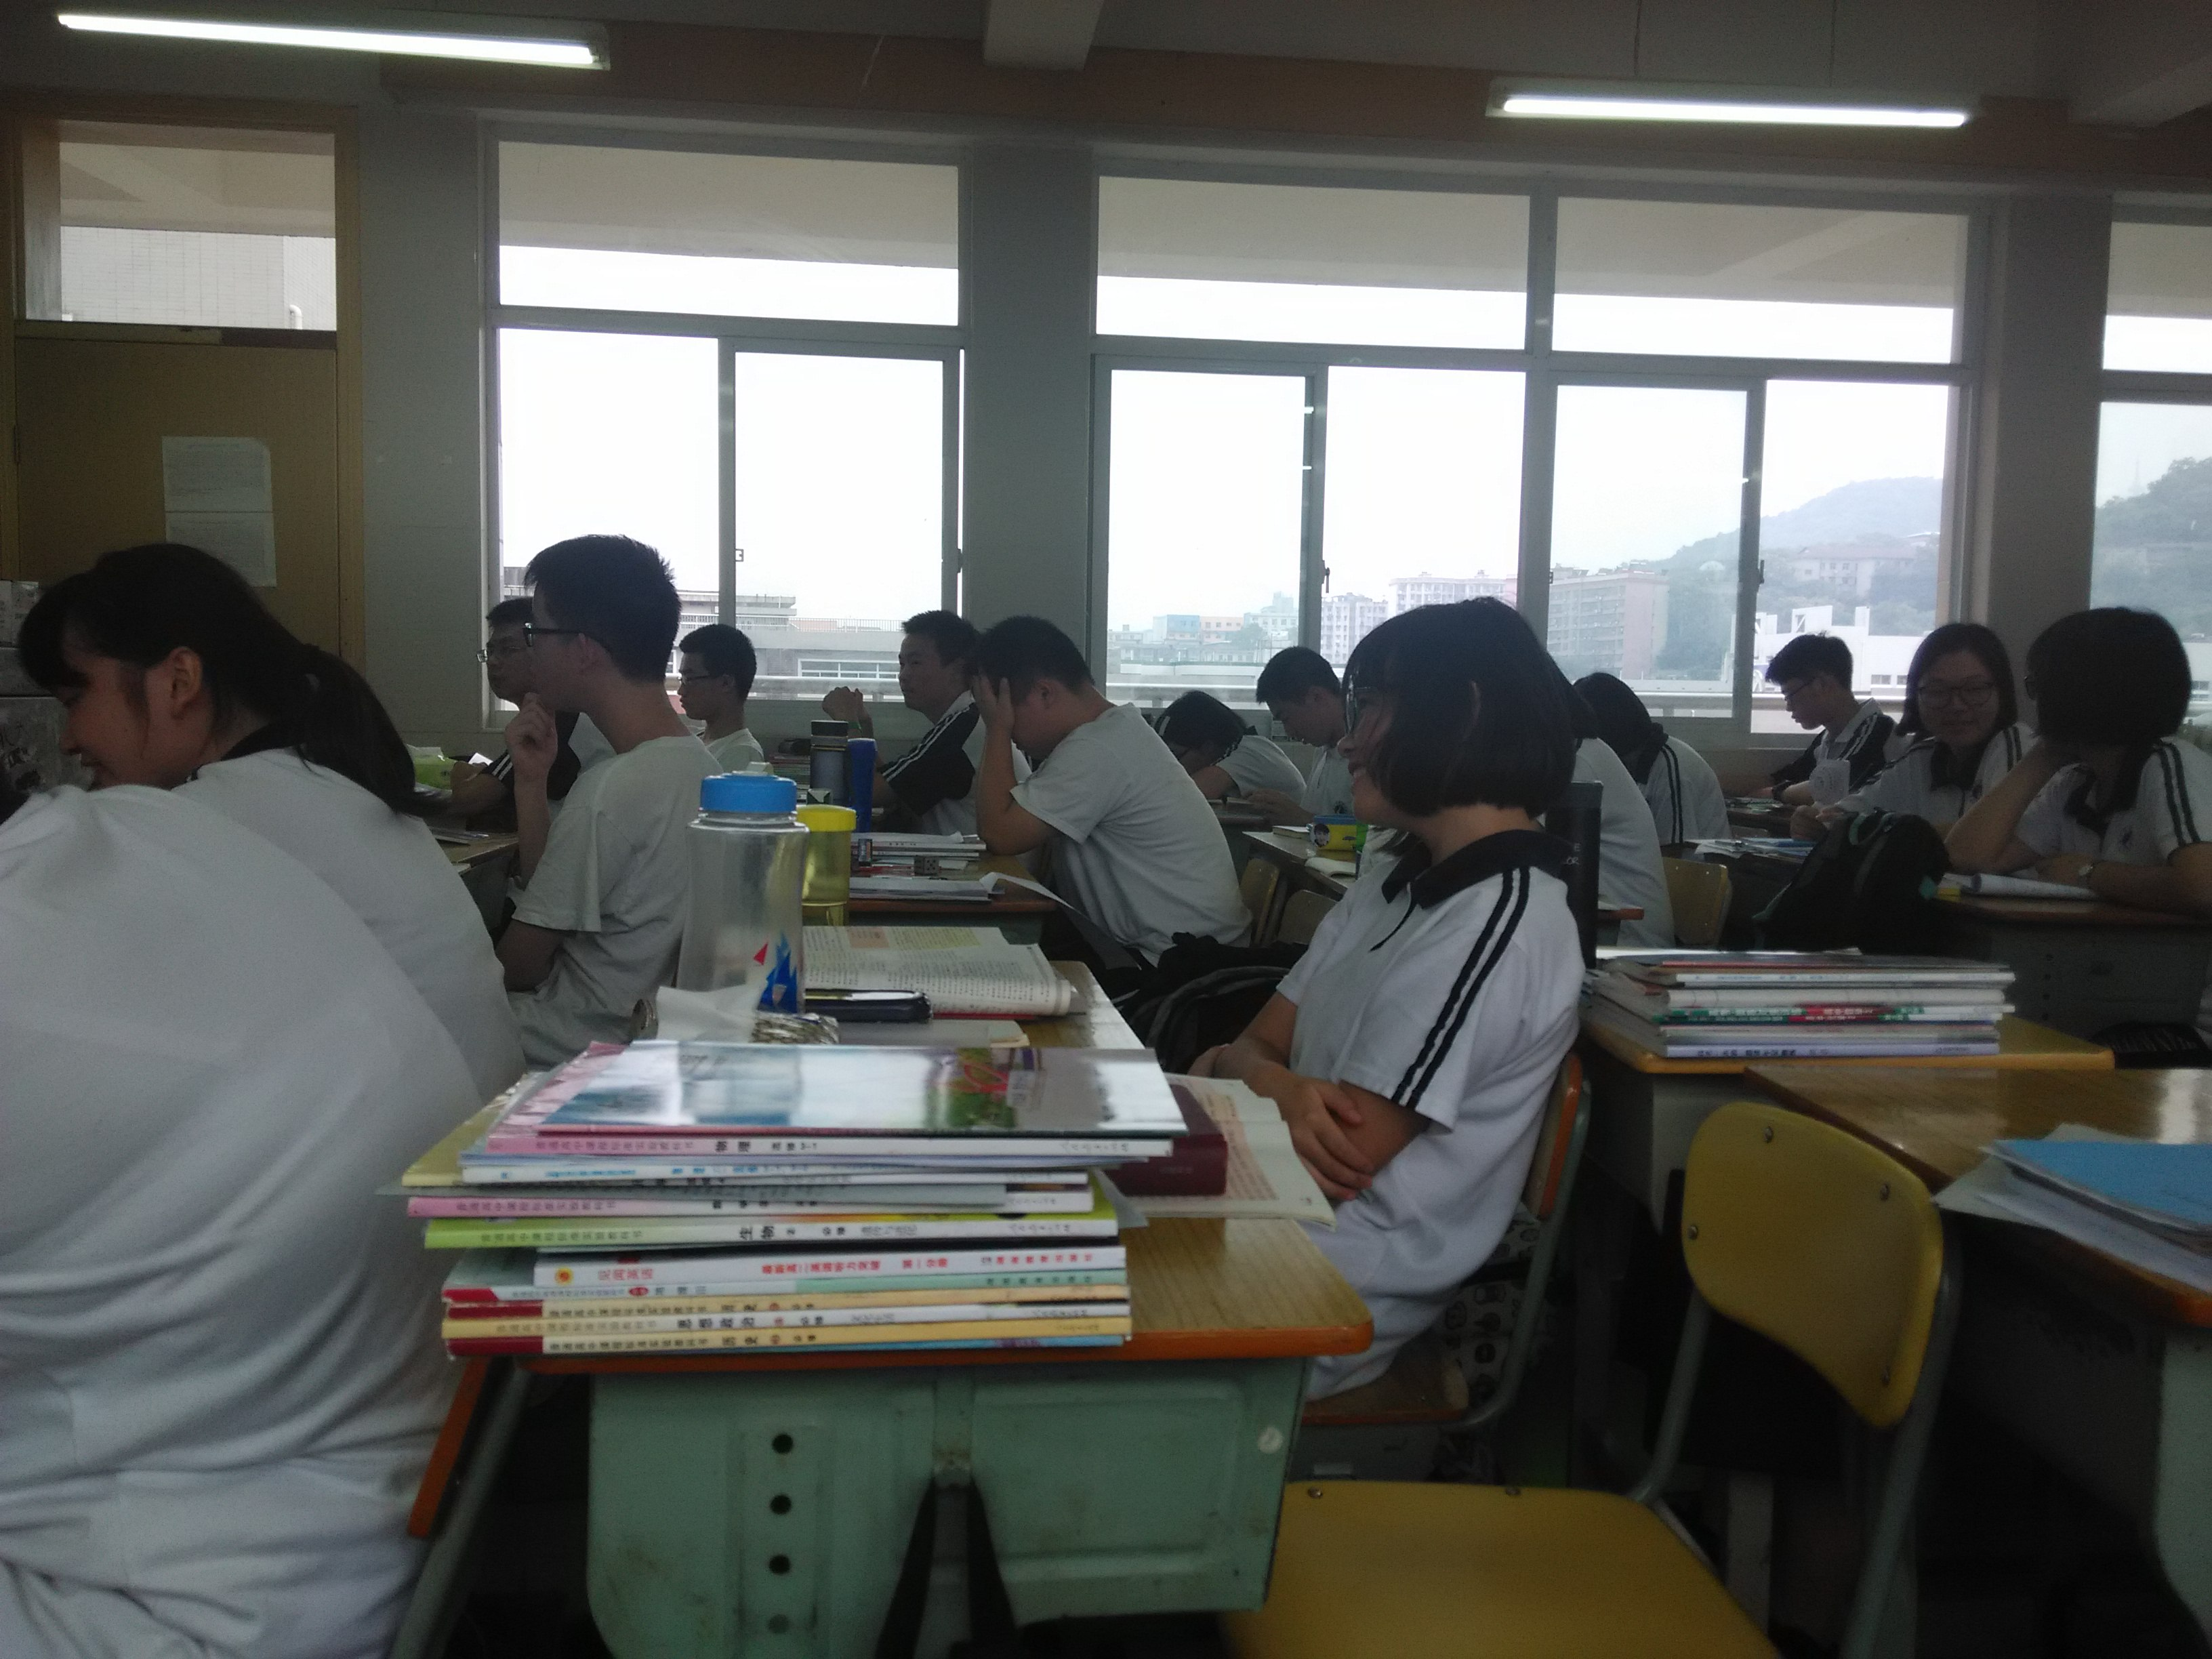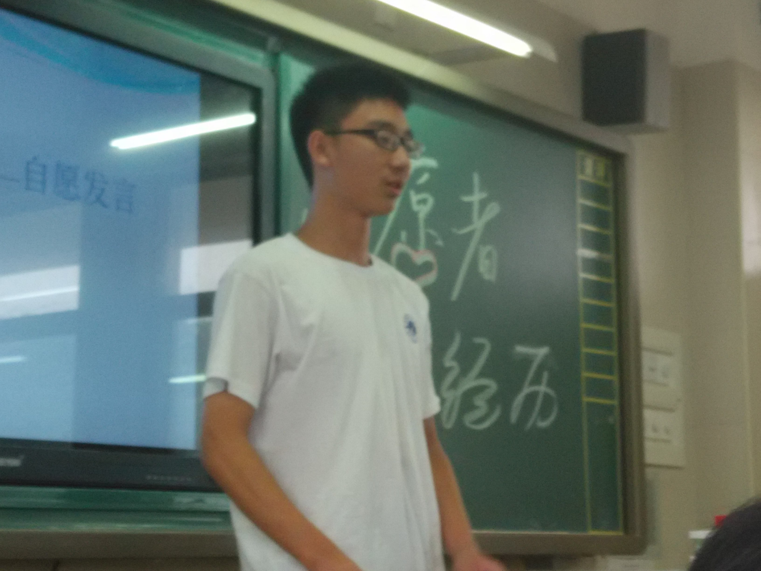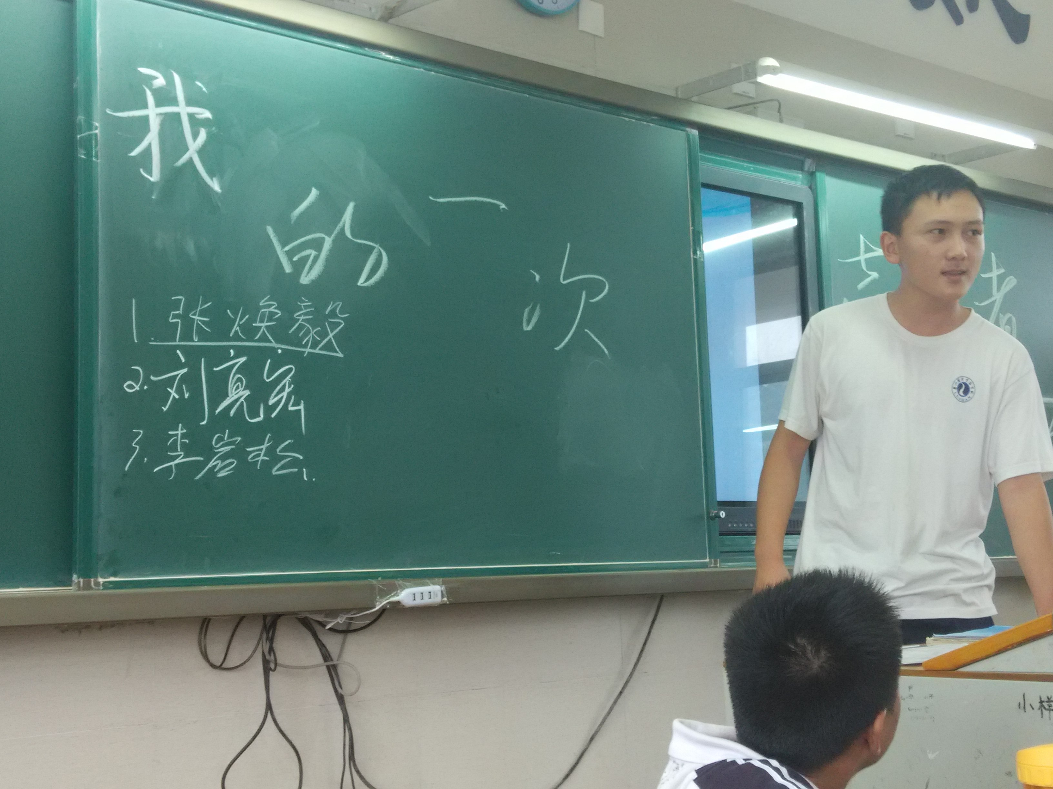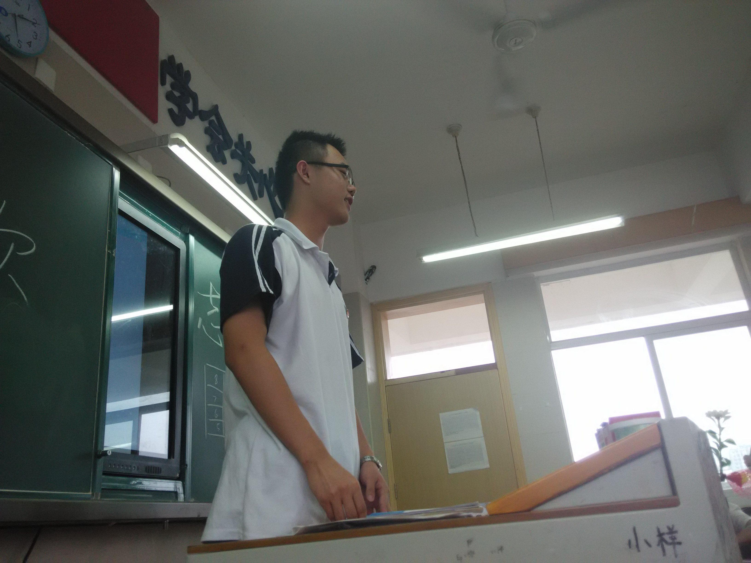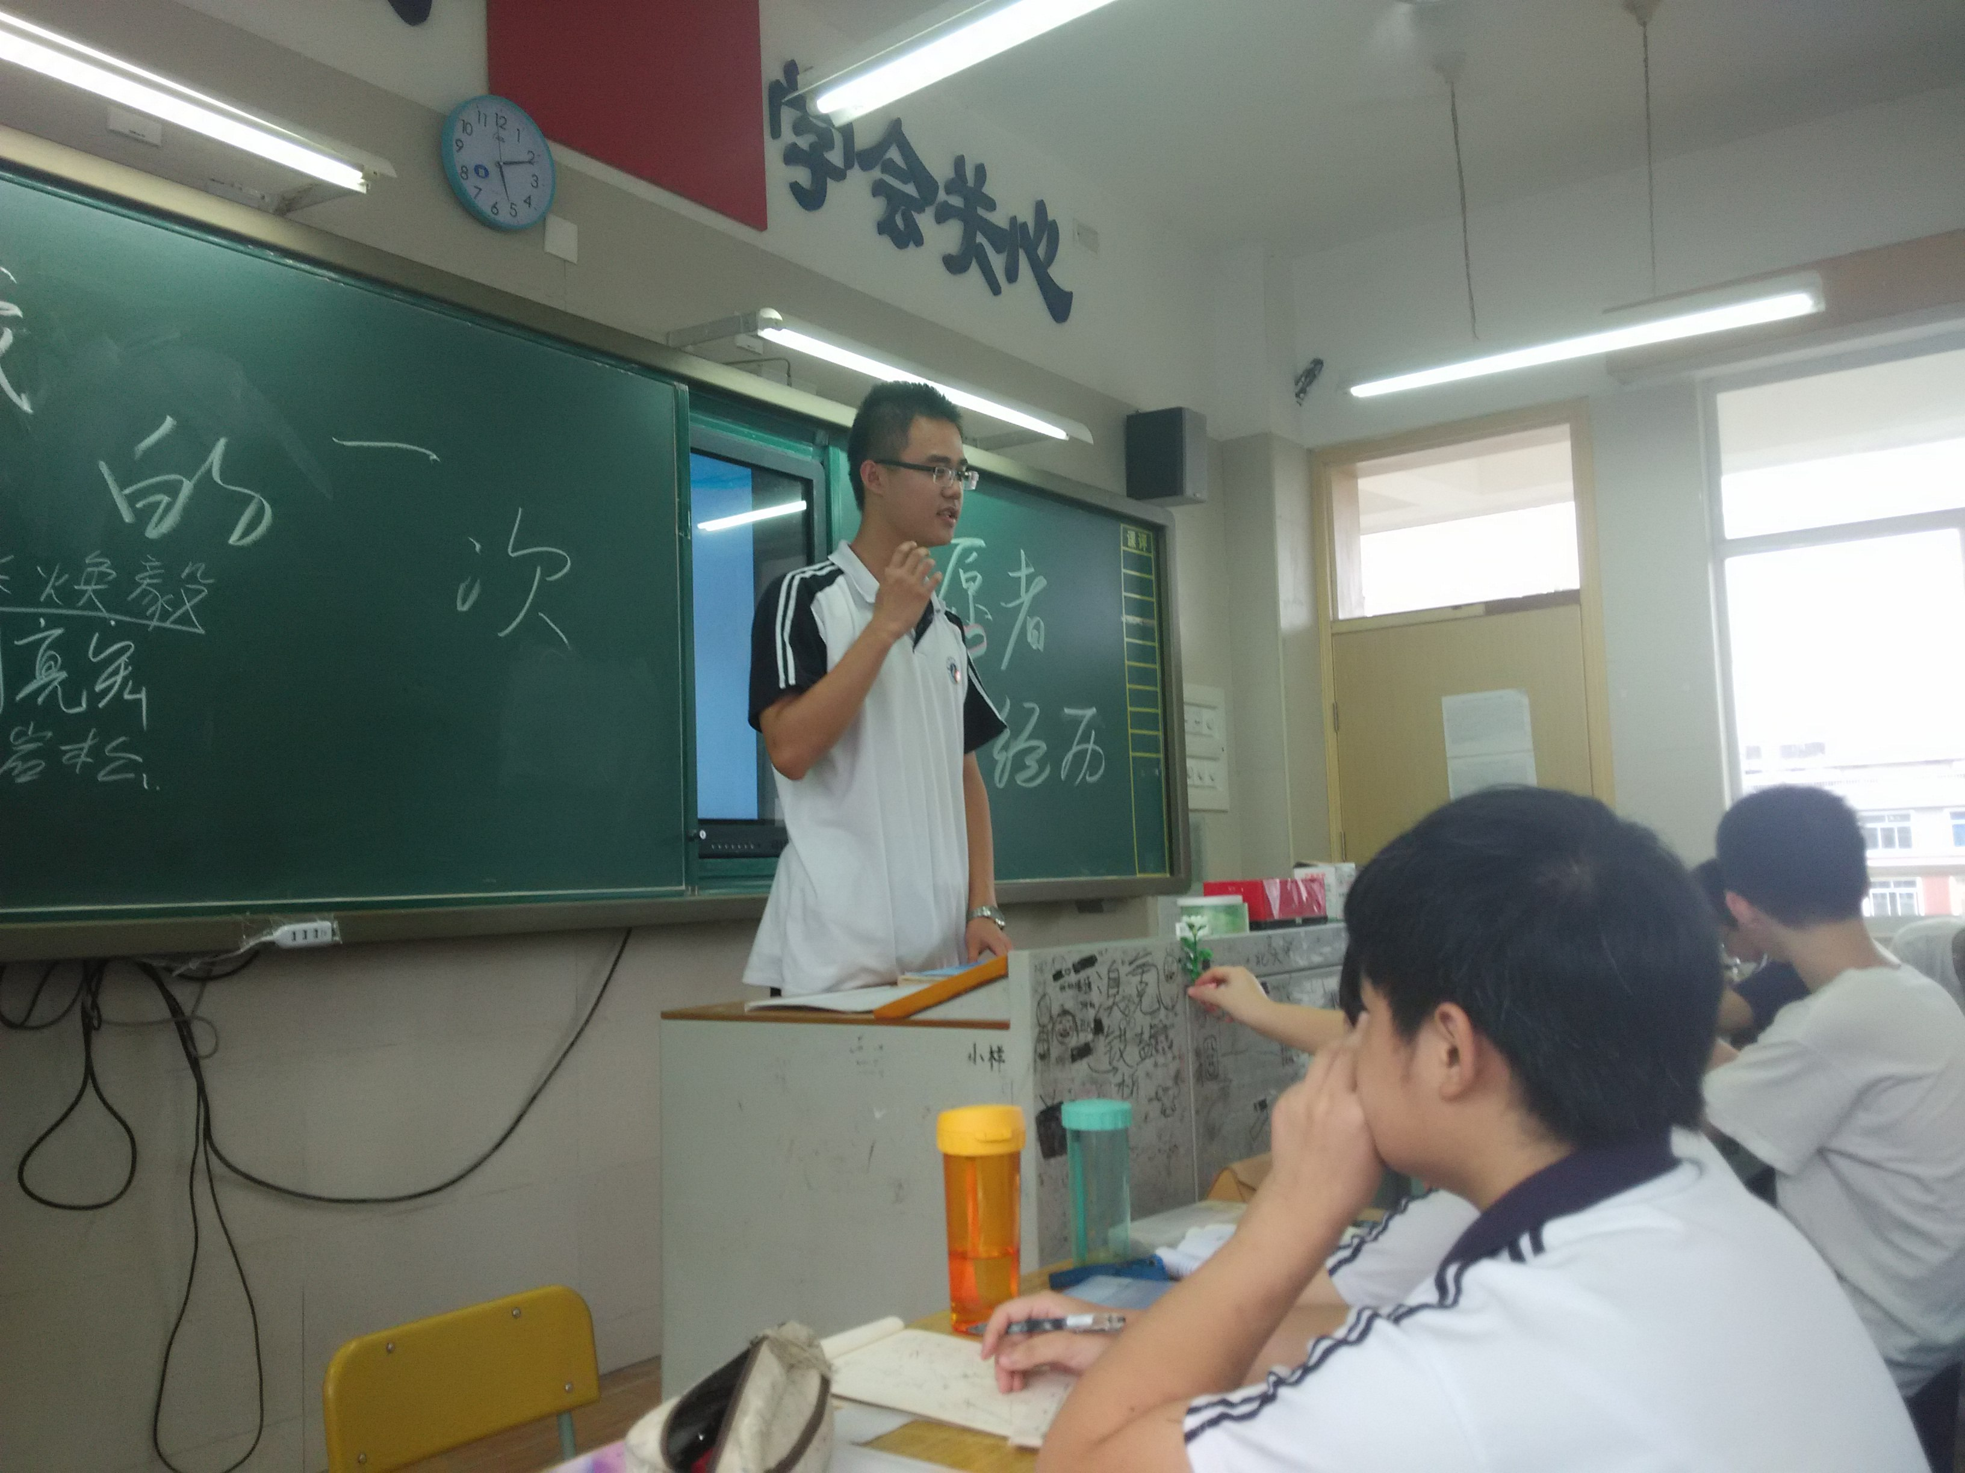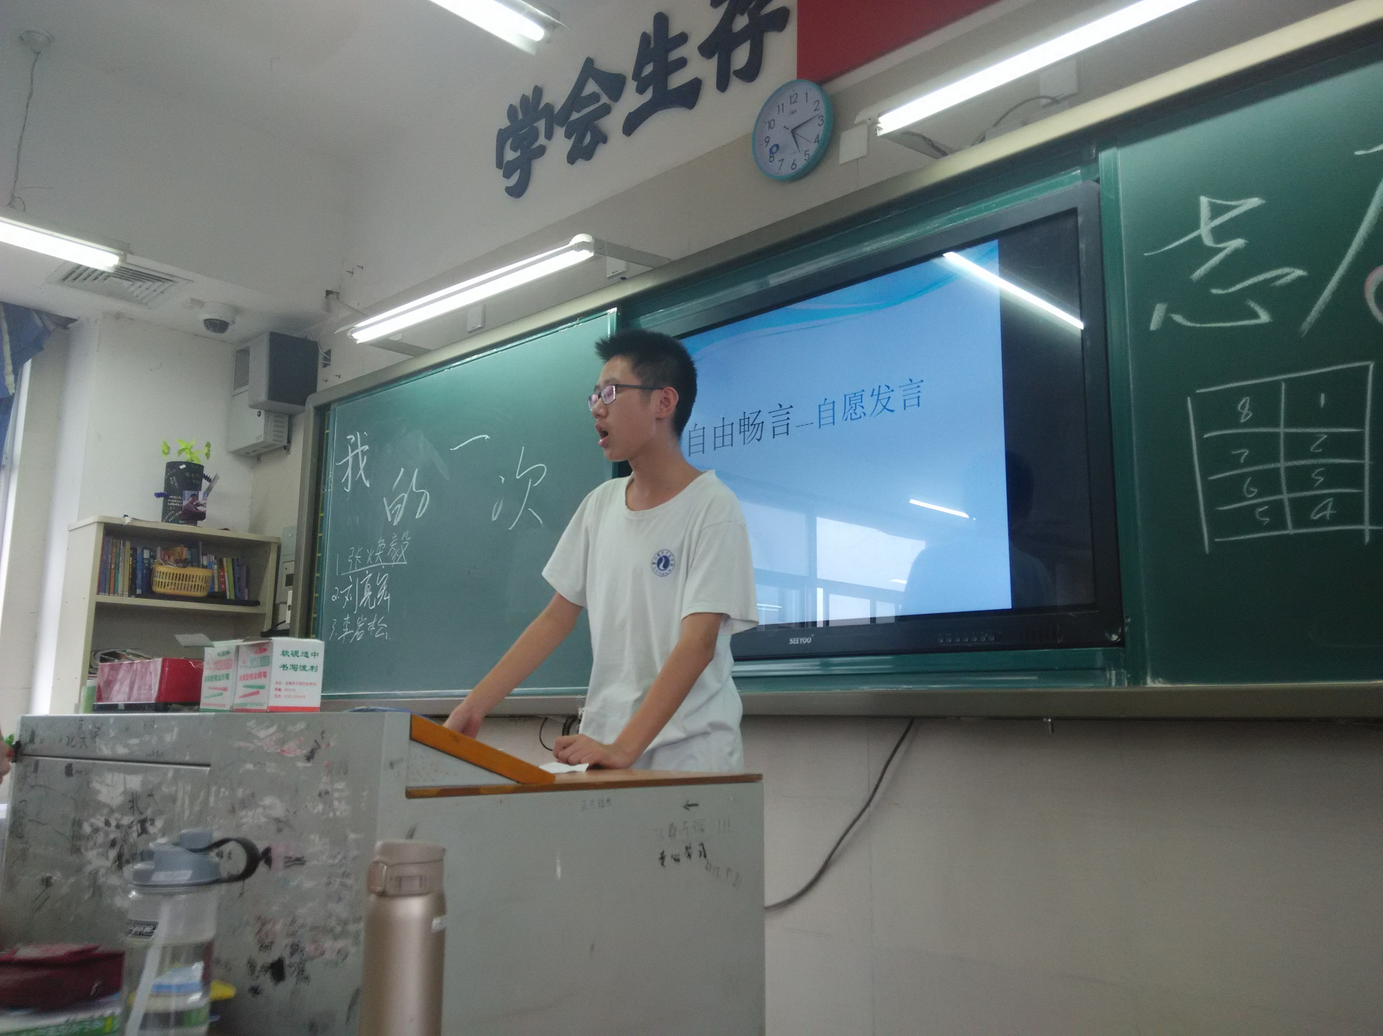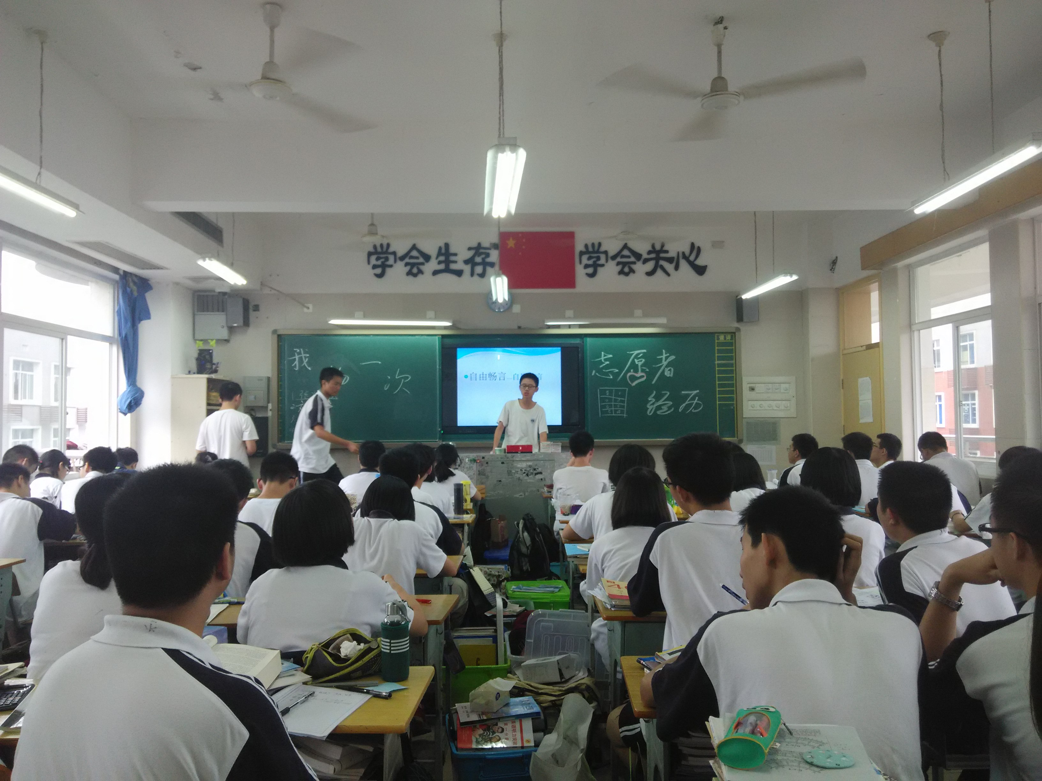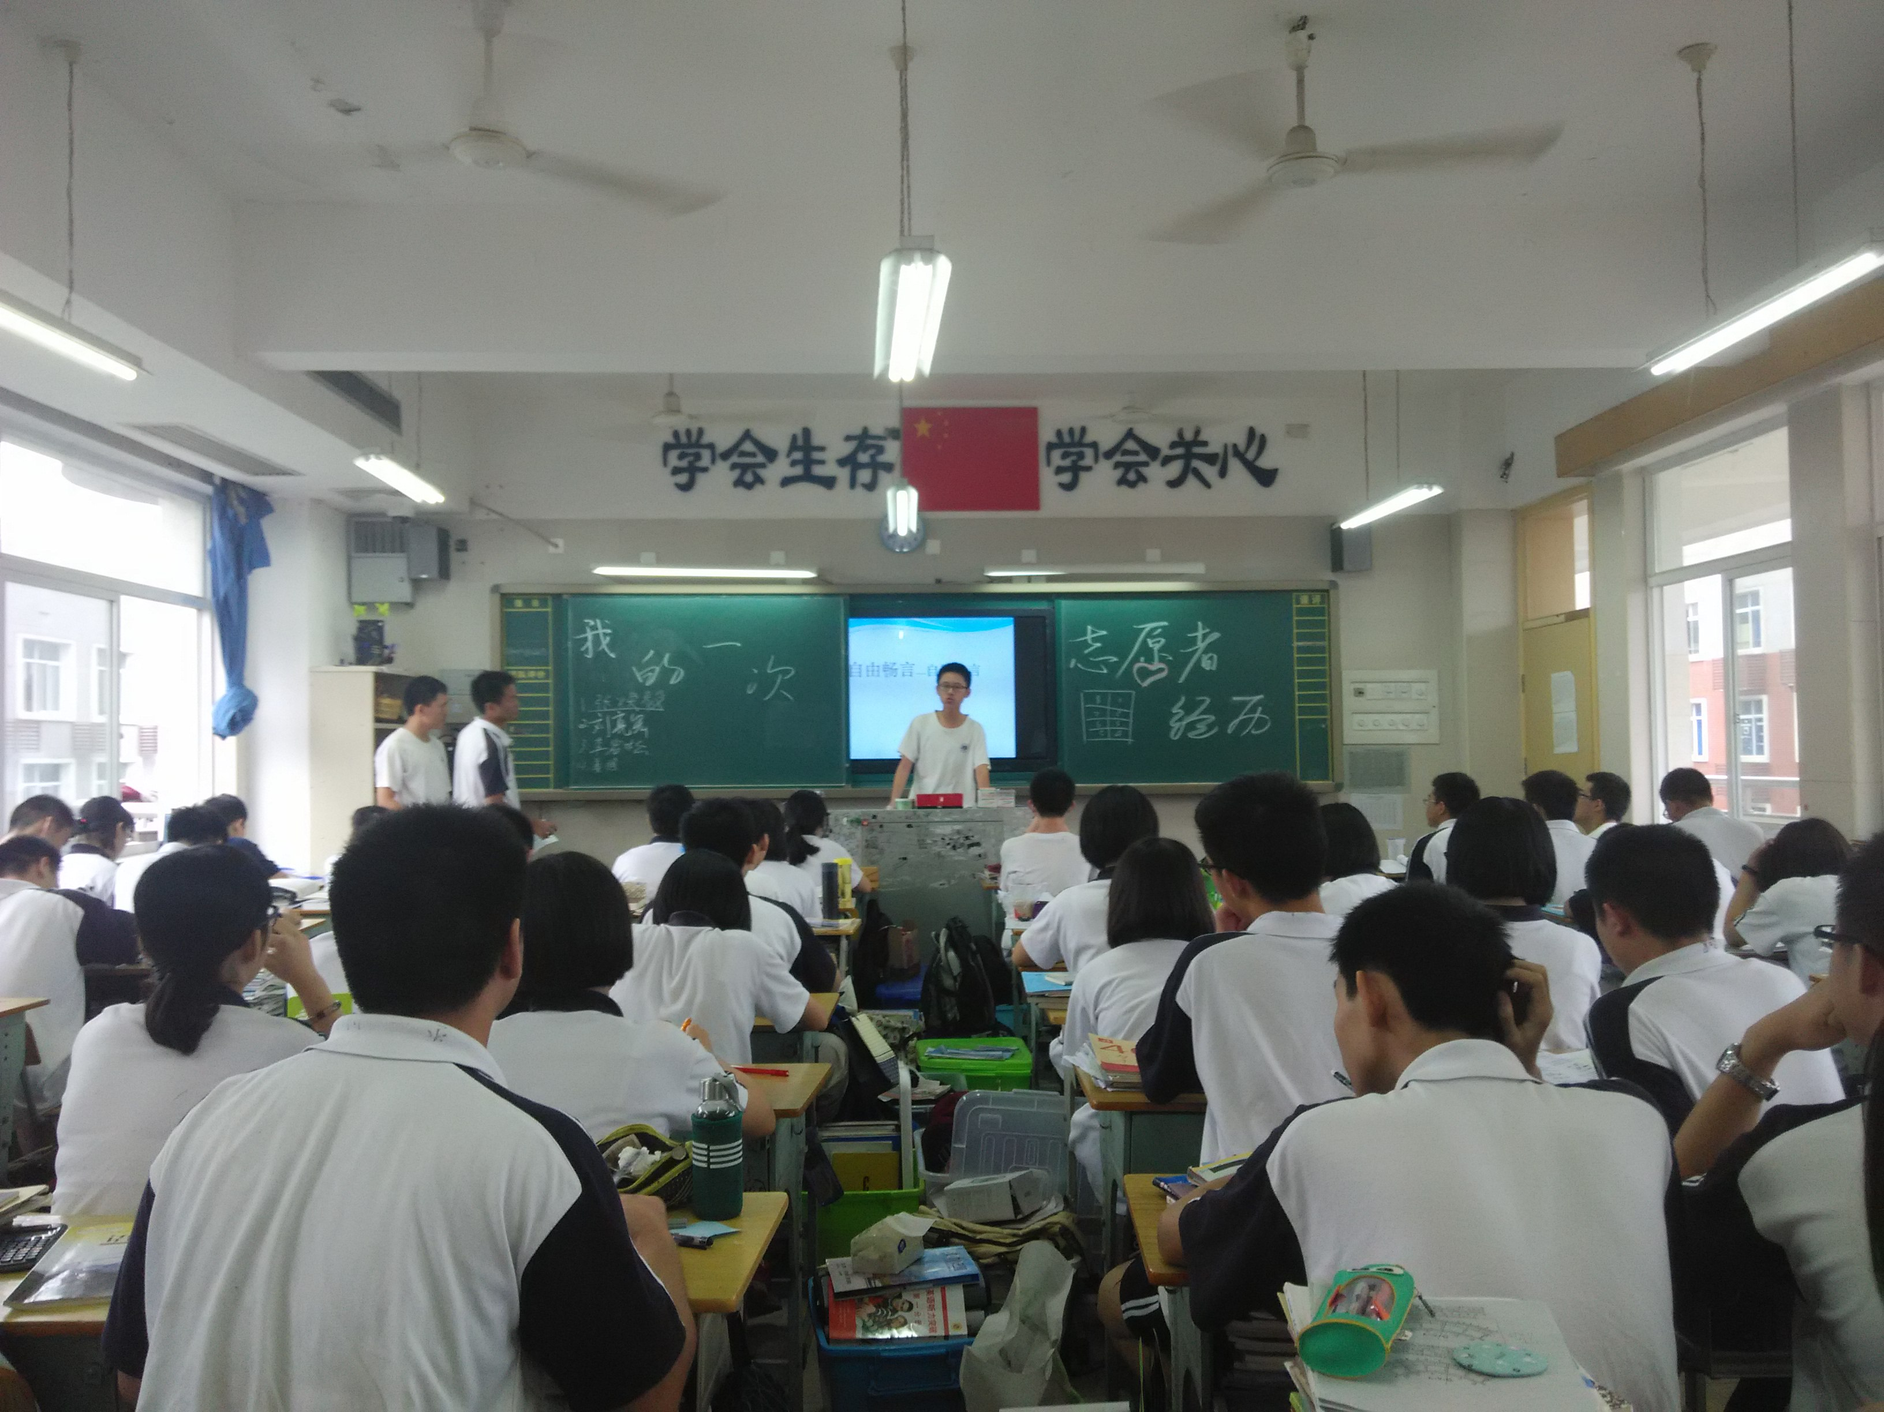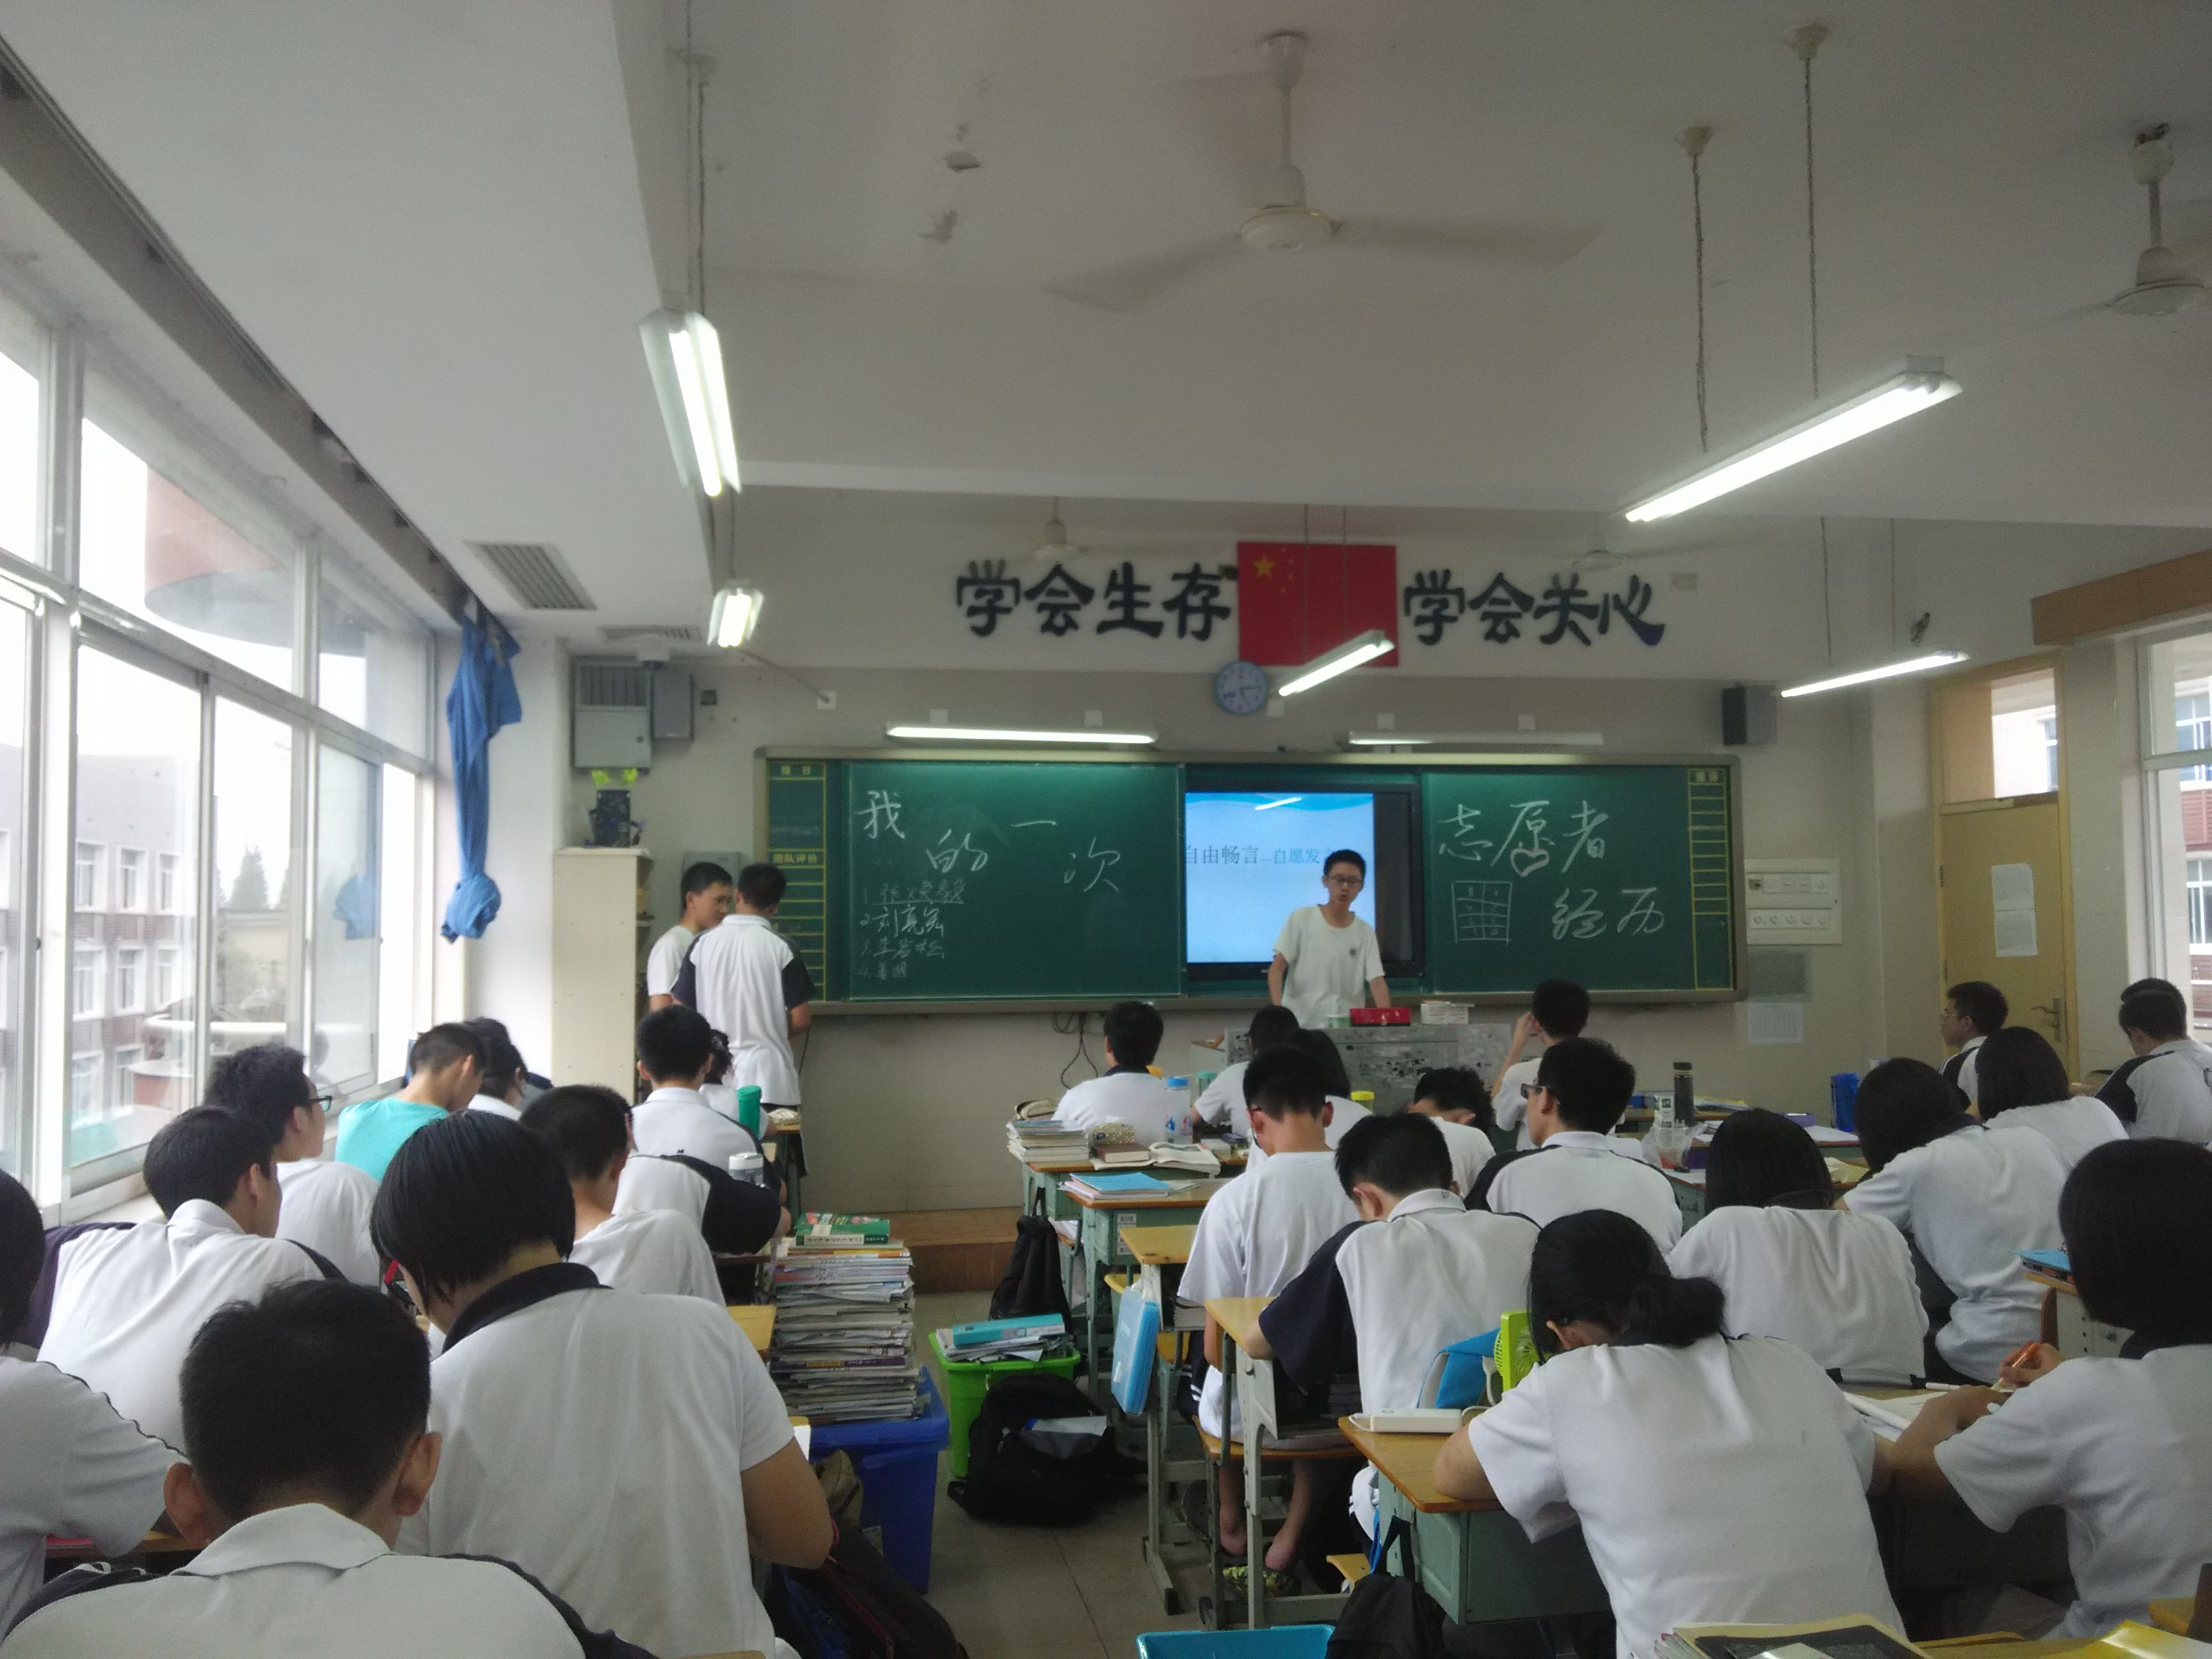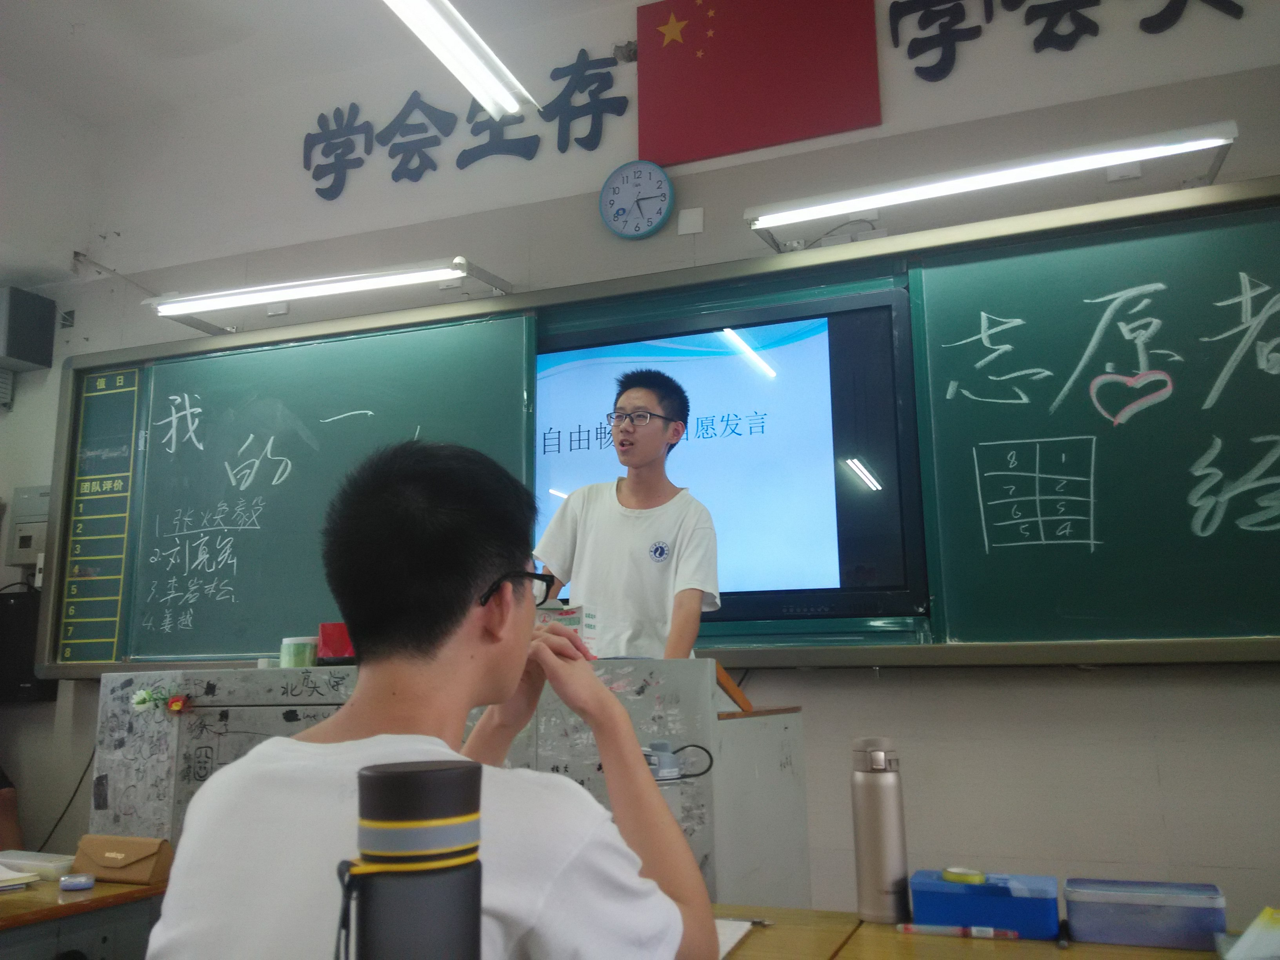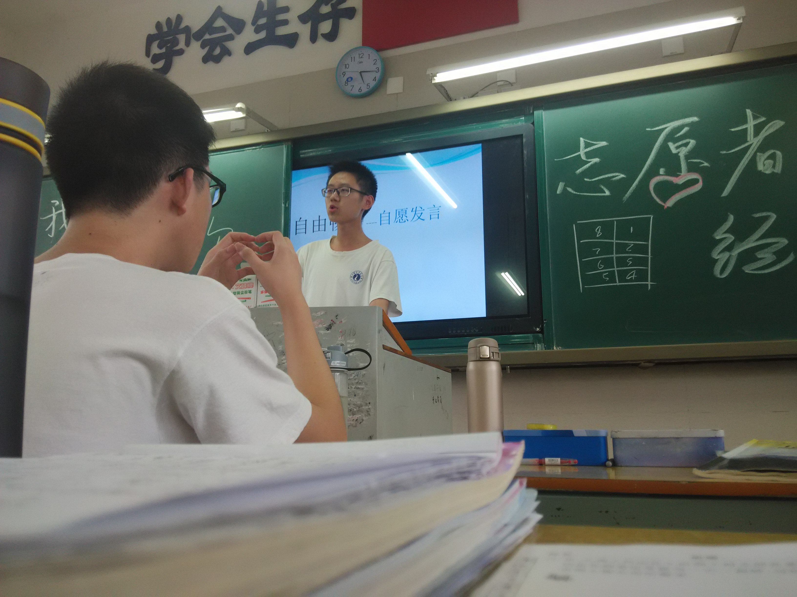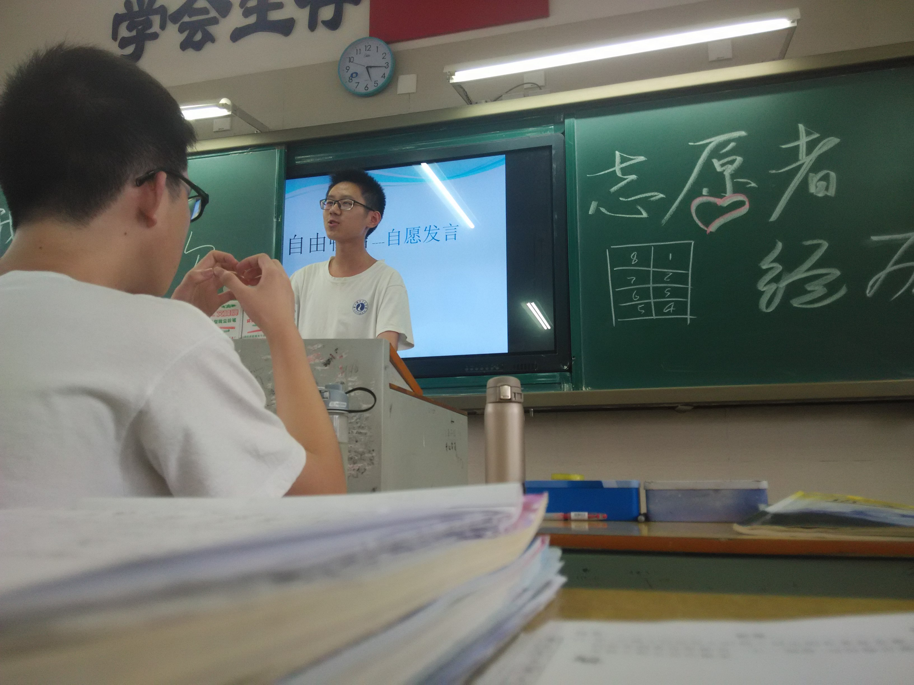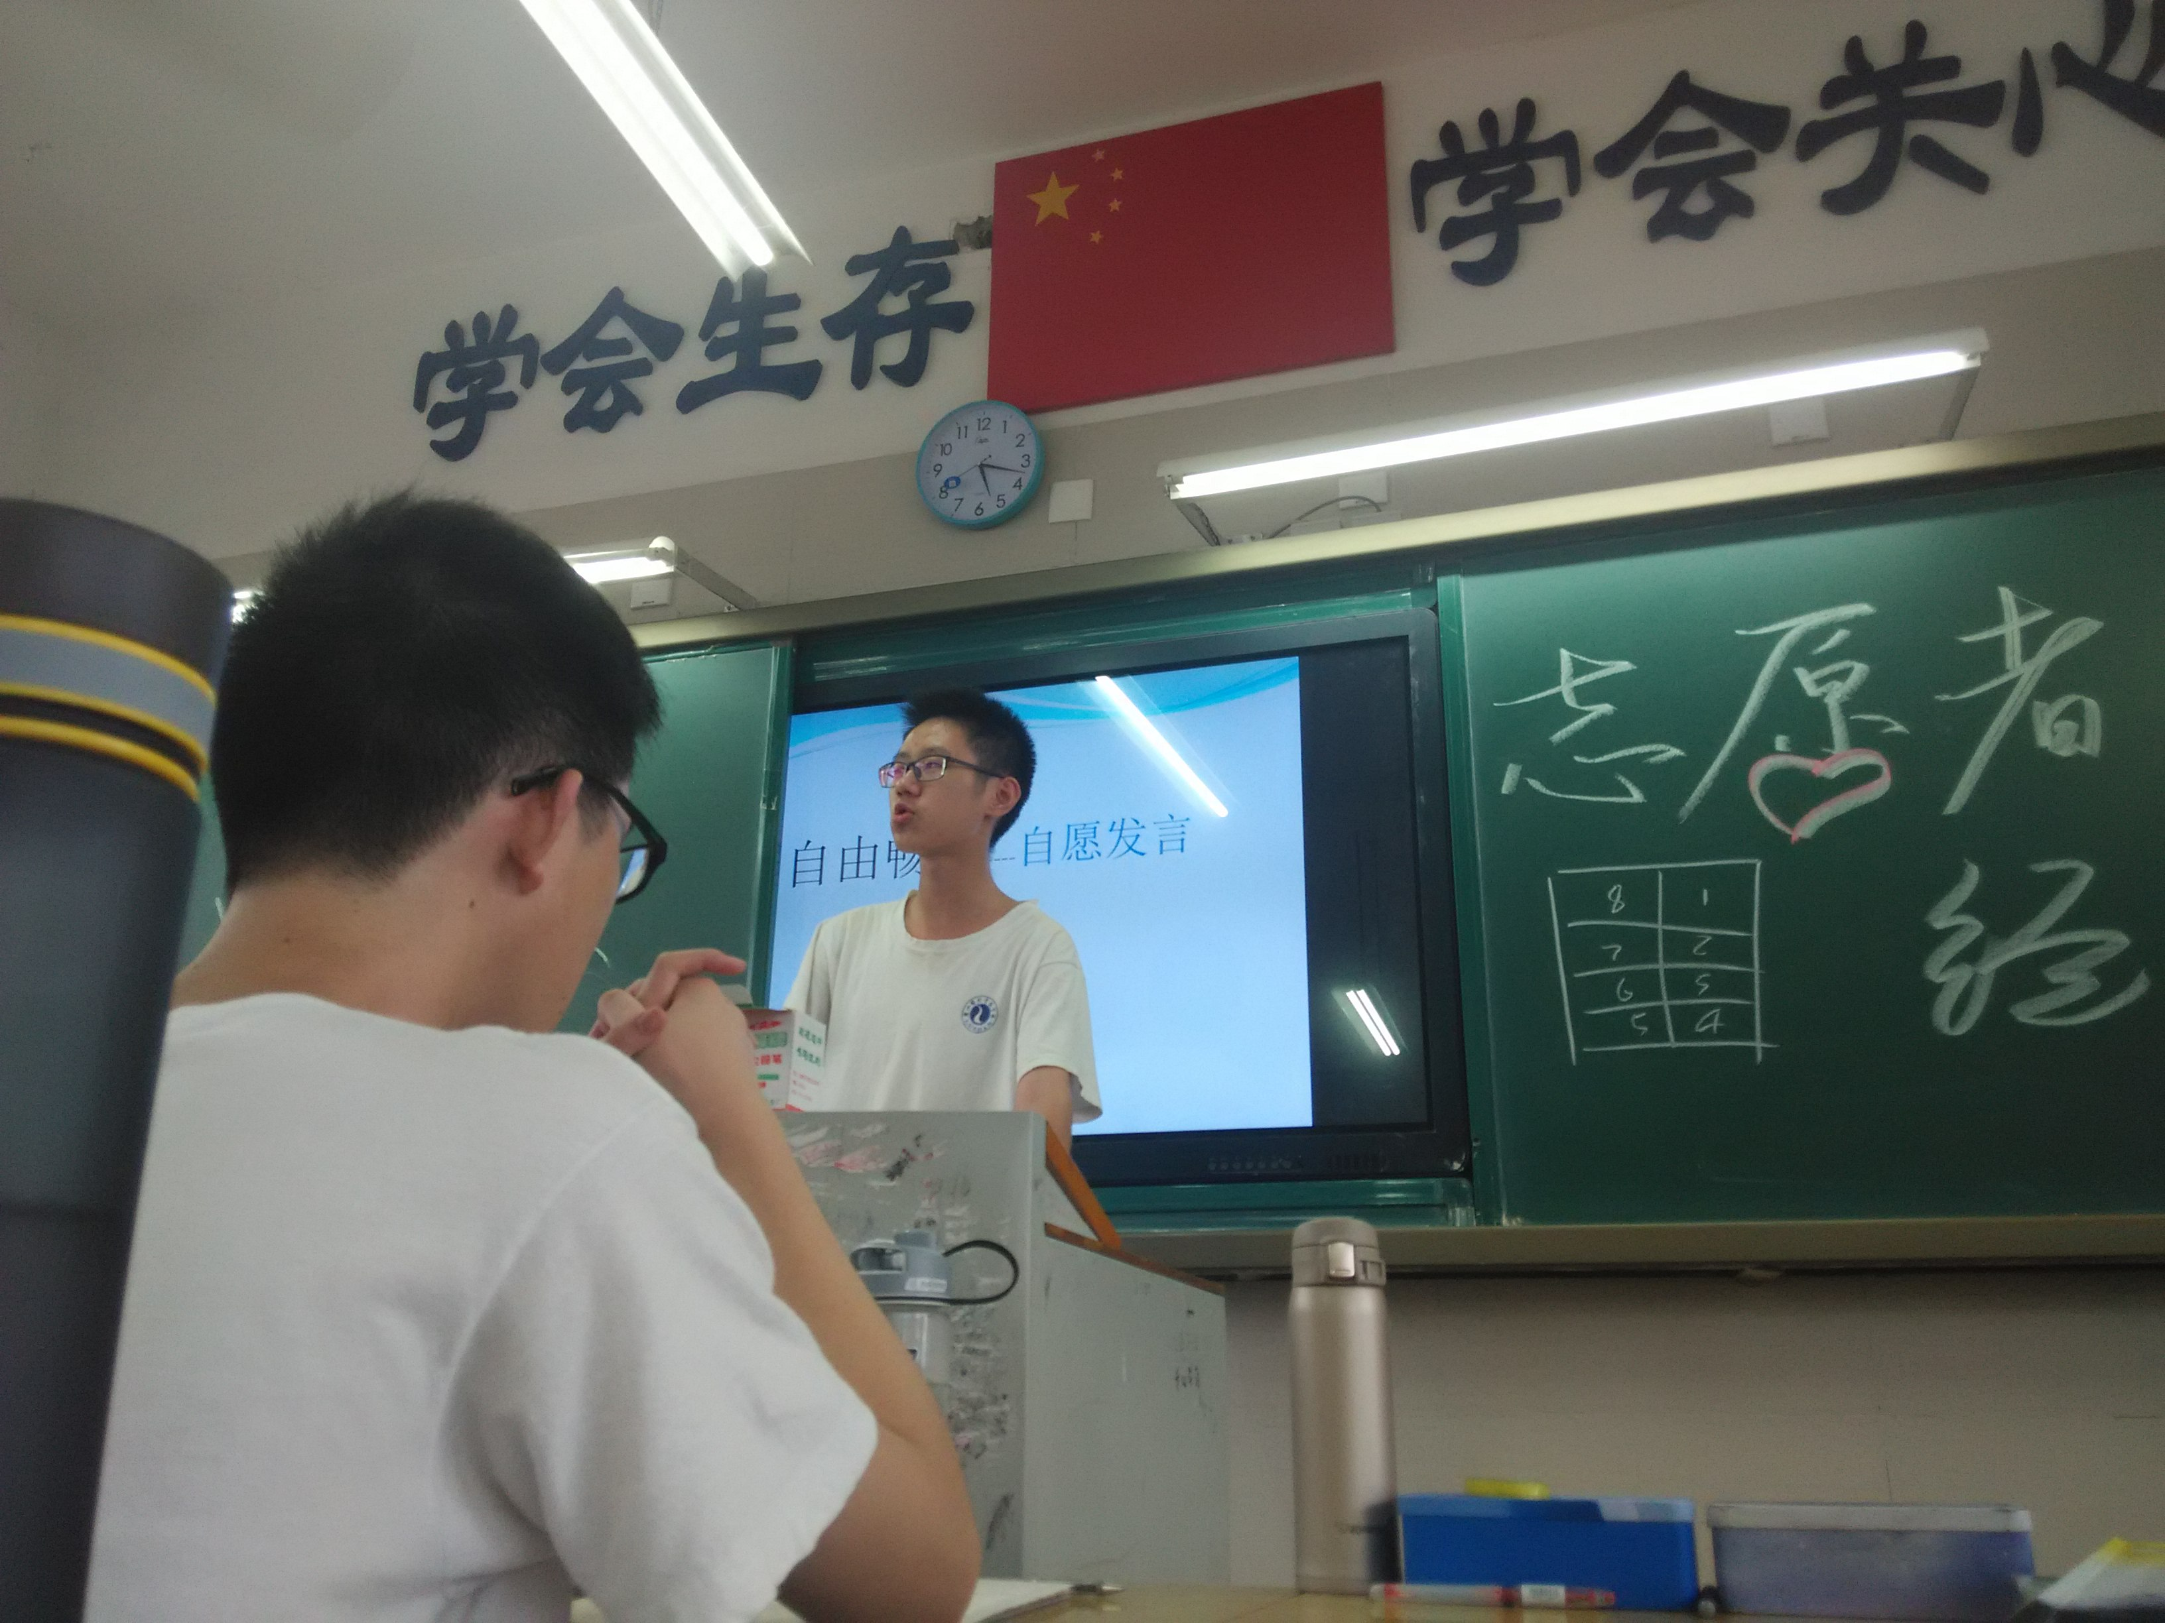

1. **优秀作业展示（本周展示人物：李敏静）**

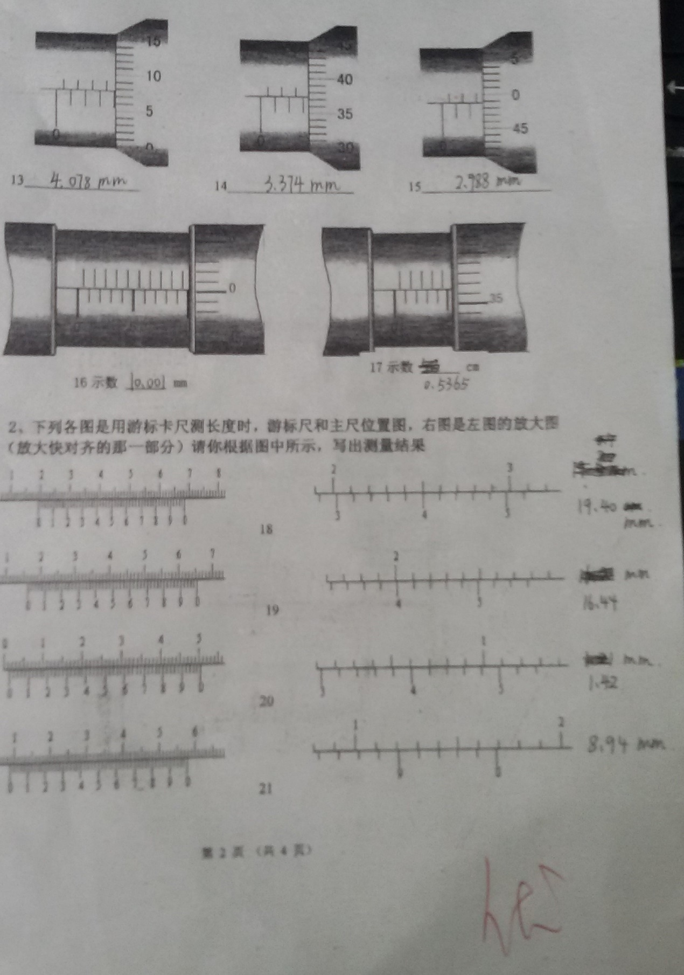

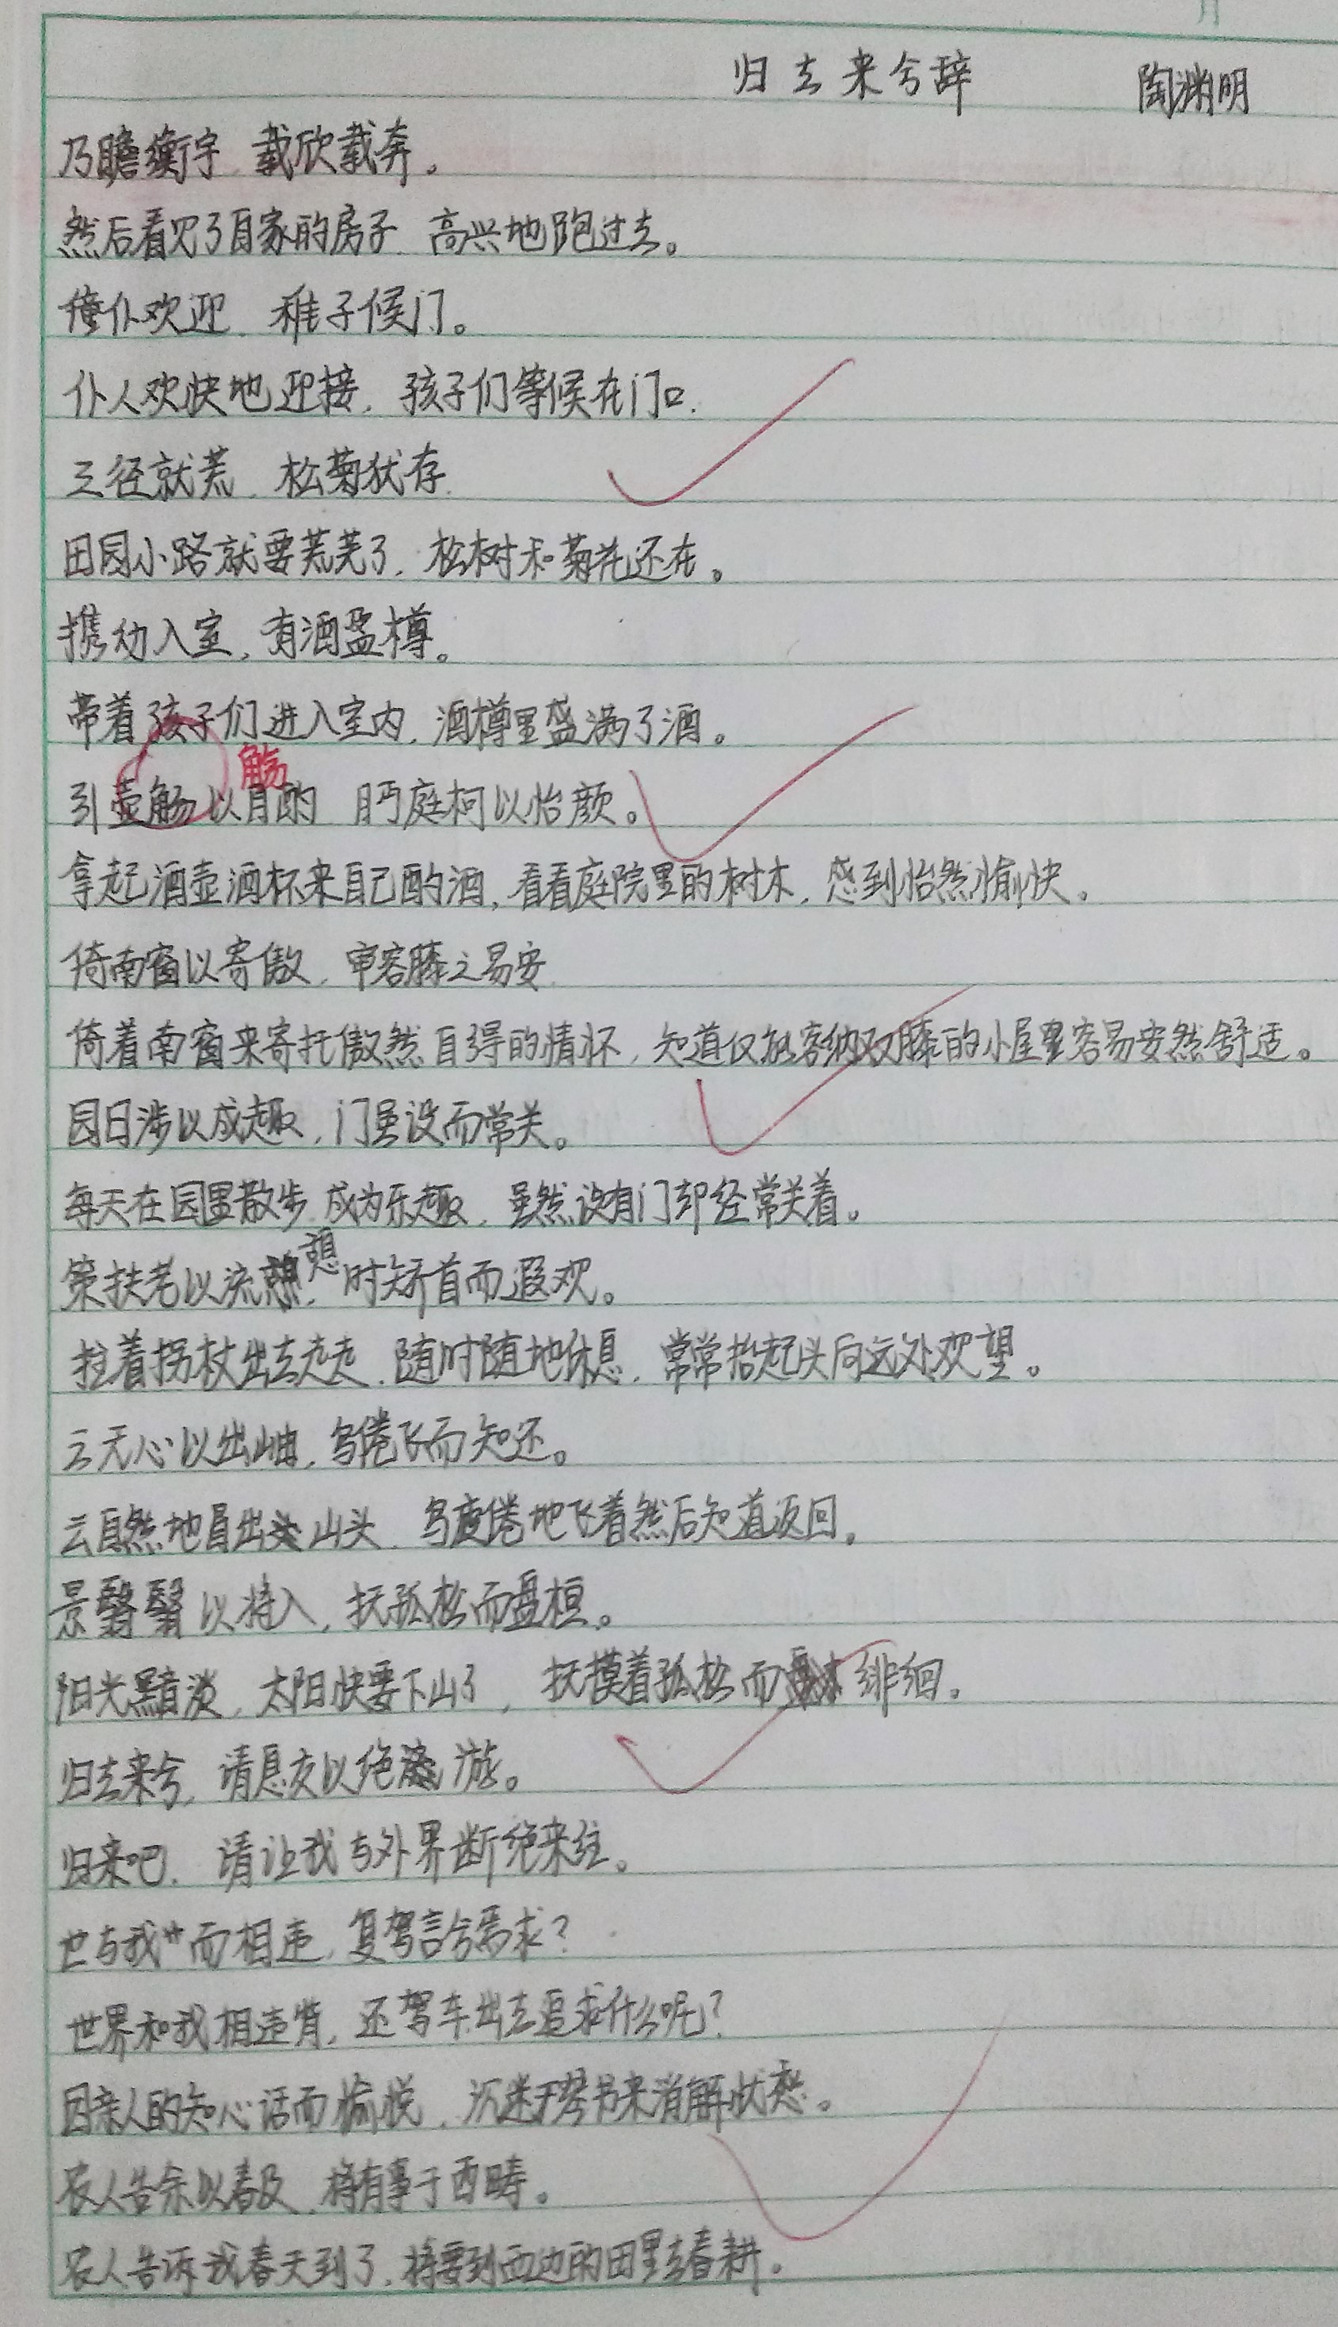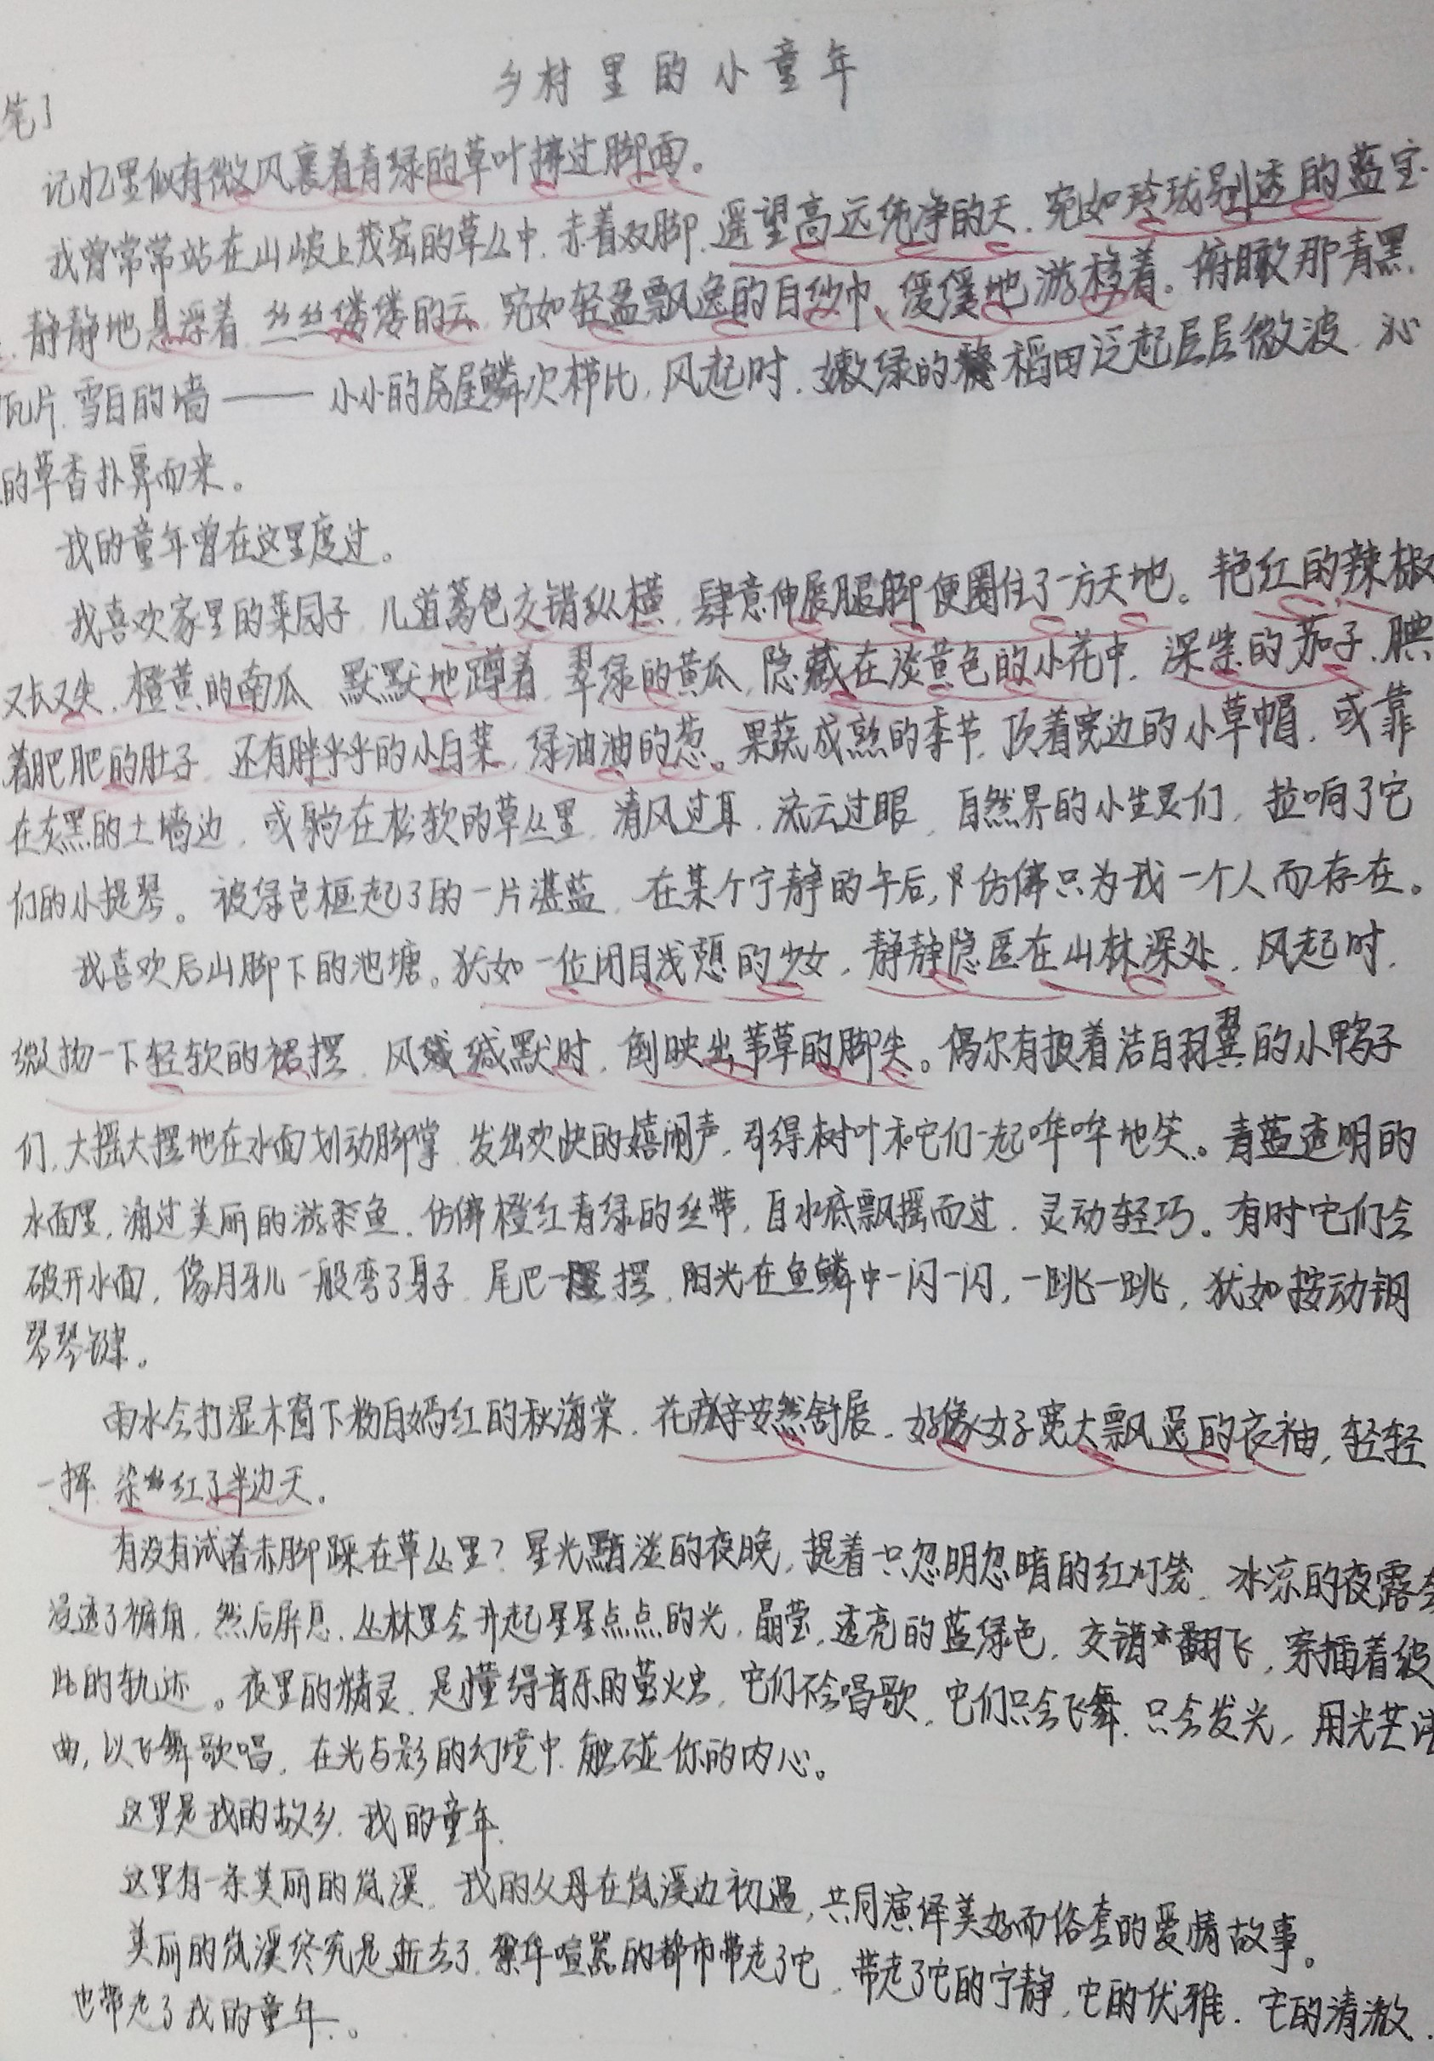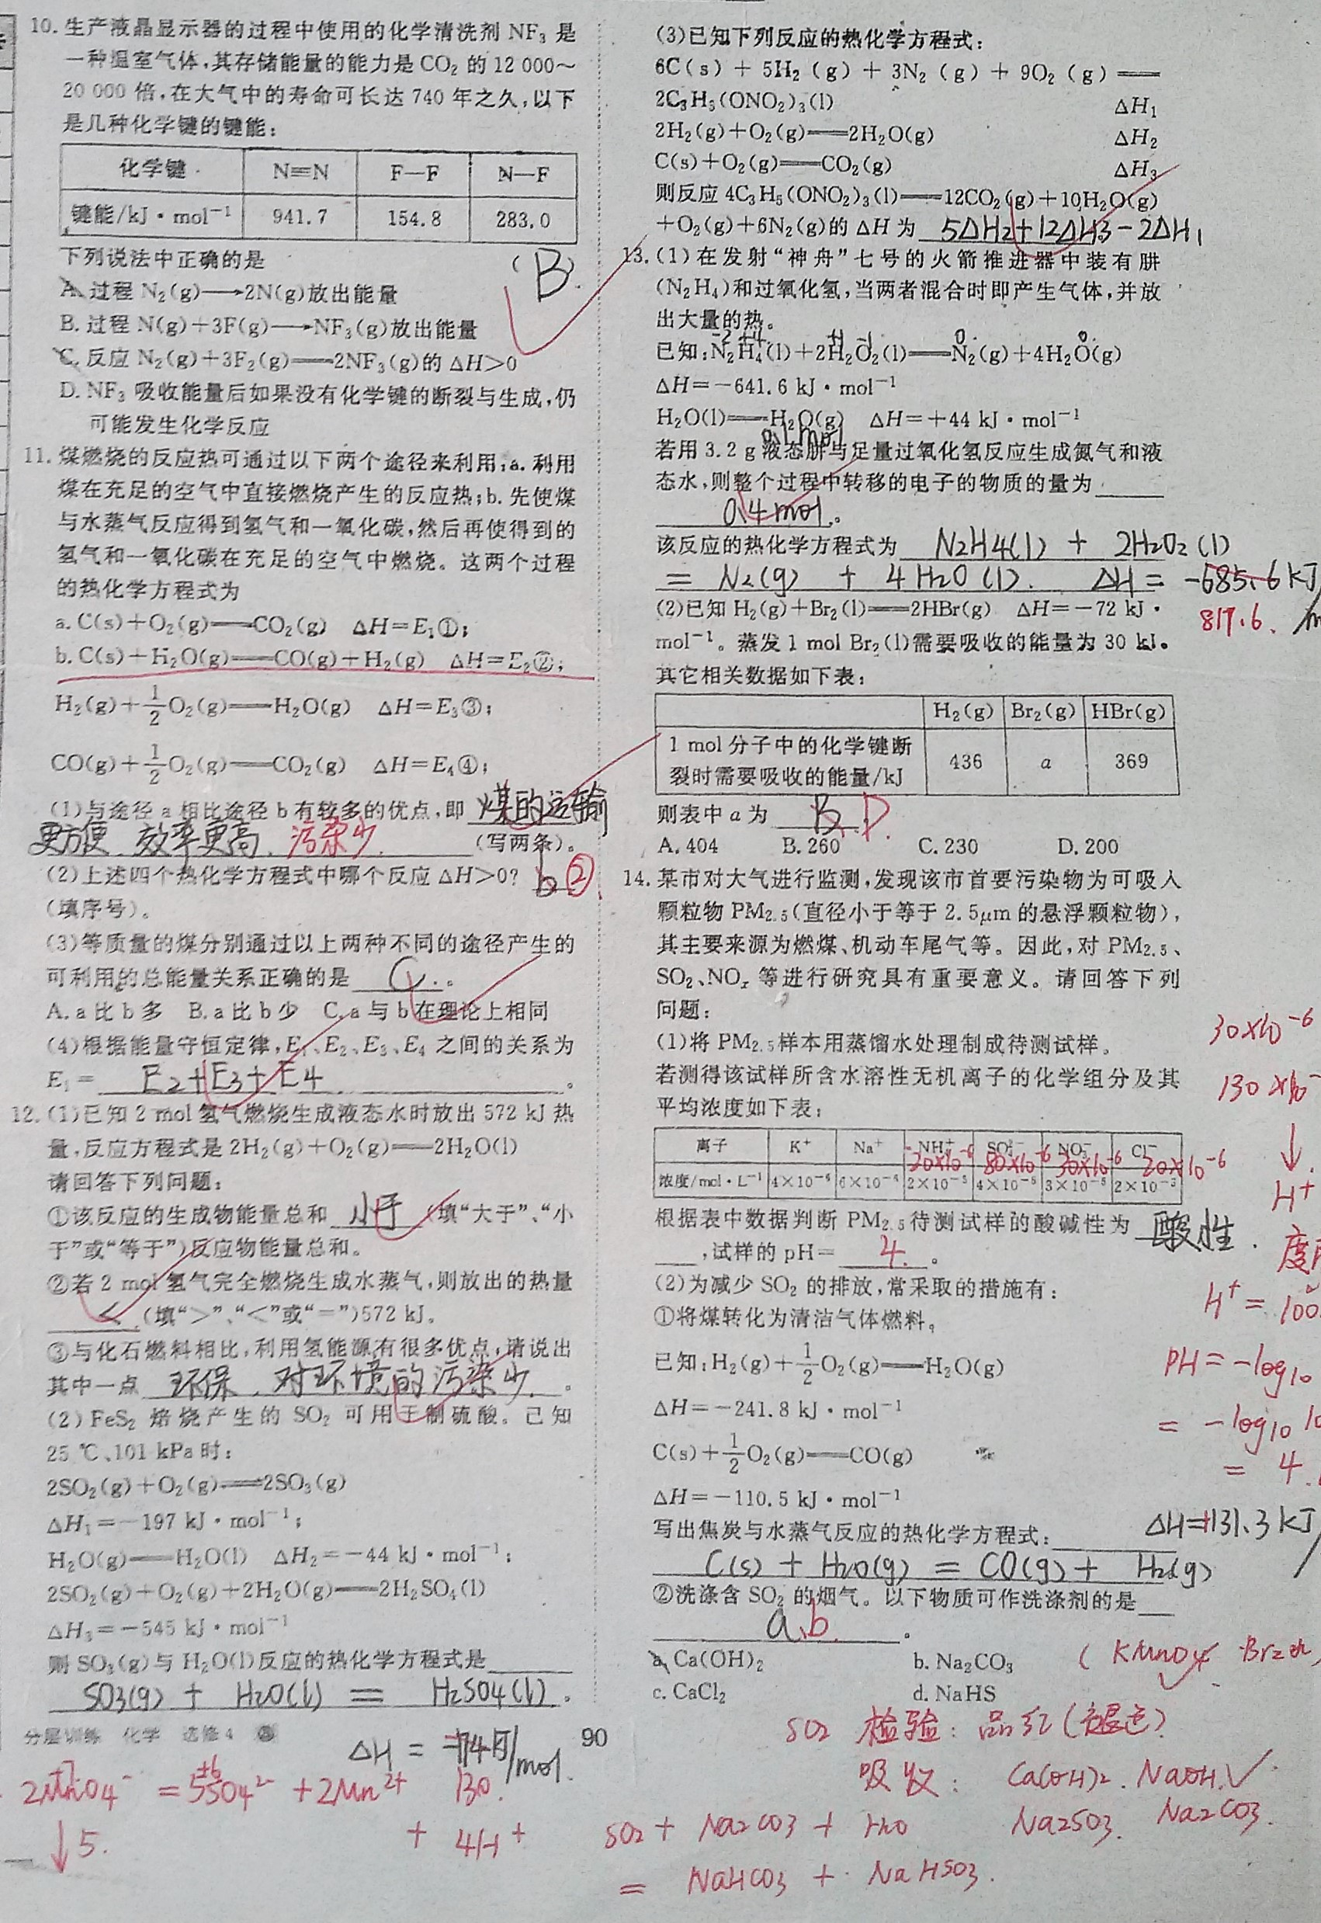

# 温馨提示

**4. 学习委员总结**

表扬

语文:丁文瑾、毛燕菲、陈乐鹏、李璇、孔玮、罗依柳、张缤尹、何泽洋、王一凡、莫依颖。

英语:刘亦迅、李彬迪、谭廷江、张焕毅、余果、黄扬基、朱宇轩、袁明智、张缤尹、张玮彤、欧阳铭。

注意：奥赛生同学本周欠作业情况严重，考虑奥赛生特殊情况，奥赛生作业可以在第二天上本科课之前交给课代表，但一定要交。

**交手机及留校生名单**

|  |  |  |  |  |  |  |  |
| --- | --- | --- | --- | --- | --- | --- | --- |
| 学号 | 姓名 | 交手机 | 留校生 | 学号 | 姓名 | 交手机 | 留校生 |
| 1 | 谭廷江 |  |  | 33 | 龙昭 | 1 | 1 |
| 2 | 何顺 |  |  | 34 | 黄扬基 | 1 | 1 |
| 3 | 何泽洋 | 1 |  | 35 | 宋建新 |  | 1 |
| 4 | 梁宇智 |  |  | 36 | 姜越 |  |  |
| 5 | 郭志文 | 1 | 1 | 37 | 熊亚军 |  |  |
| 6 | 张恬铭 |  |  | 38 | 钟梓鸣 | 1 |  |
| 7 | 袁民智 |  | 1 | 39 | 吴劼远 |  |  |
| 8 | 王一凡 | 1 |  | 40 | 李彬迪 |  |  |
| 9 | 李子璐 | 1 |  | 41 | 王清荷 |  | 1 |
| 10 | 谢志浩 | 1 |  | 42 | 莫依颖 |  |  |
| 11 | 孔玮 | 1 | 1 | 43 | 李思云 |  | 1 |
| 12 | 阎逸 | 1 | 1 | 44 | 张玮彤 | 1 |  |
| 13 | 何孟宇 | 1 | 1 | 45 | 毛燕菲 | 1 |  |
| 14 | 欧阳铭 |  |  | 46 | 李敏静 |  | 1 |
| 15 | 佘科宇 | 1 |  | 47 | 白芳雯 |  |  |
| 16 | 陈俊廷 | 1 |  | 48 | 许薇梓 | 1 |  |
| 17 | 张焕毅 |  |  | 49 | 罗依柳 |  |  |
| 18 | 黄智 |  | 1 | 50 | 舒晴 |  |  |
| 19 | 蒋少康 |  |  | 51 | 陈乐鹏 | 1 | 1 |
| 20 | 李岩松 |  | 1 | 52 | 丁文瑾 | 1 |  |
| 21 | 徐梓轶 |  |  | 53 | 刘亦迅 |  |  |
| 22 | 朱宇轩 |  |  | 54 | 雷佳欣 |  |  |
| 23 | 谭毅 | 1 |  | 55 | 姚晨 | 1 |  |
| 24 | 董正浩 |  |  | 56 | 李璇 |  |  |
| 25 | 刘亮宏 |  | 1 | 57 | 李钰涵 |  |  |
| 26 | 王豪捷 |  |  | 58 | 张缤尹 |  |  |
| 27 | 周志宇 |  |  | 59 | 曹茜媛 | 1 |  |
| 28 | 刘雨祺 | 1 | 1 | 60 | 余果 |  |  |
| 29 | 张宇东 |  |  | 61 | 夏雨聪 |  | 1 |
| 30 | 李晶 | 1 |  | 62 | 黄源祺 |  | 1 |
| 31 | 贺子亮 | 1 |  | 63 | 尹琦钰 |  | 1 |
| 32 | 杨邵金林 |  | 1 | 64 | 罗悦菲_ |  |  |

**作业**